Lecture VII
Antipsychotics (Tranquilizers)
Psychotic illness is a compilation of multiple disorders, including schizophrenia, the manic phase of bipolar syndrome, acute idiopathic psychosis, and other conditions marked by severe agitation,56 yet the term “psychosis” is most often associated with schizophrenia. Schizophrenia affects approximately 1% of the U.S. population,57 with both genetic58 and neurodevelopmental59 implications. Schizophrenia is characterized by delusions, abnormal behaviors, hallucinations, and thought disorders (i.e., positive symptoms), as well as loss of normal emotions, abilities, and motivation (i.e., negative symptoms). Although the etiology of schizophrenia is unknown, the principal neurochemical theories focus on DA60 and, more recently, on glutamate and serotonin.61,62 Much of our current knowledge of the mechanisms involved in schizophrenia has come from analyzing effects of antipsychotic drugs. The DA hypothesis of schizophrenia (DHS) has been the principal neurochemical theory of schizophrenia for more than 30 years. The basis of the DHS lies in the capacity of antipsychotic drugs to block DA receptors (D2 receptor subtype) positively correlated to their clinical potency in alleviating the symptoms of schizophrenia.60,63 Nevertheless, the observed inactivity of D2-antagonists in some individuals with schizophrenia and the pharmacological independence of positive and negative symptoms indicate further level of complexity. Other variants of the DHS suggest an imbalance between dopamingeric pathways, which may be phasic in nature.64,65 With regard to symptomology, it is thought that a dysregulation in the mesocortical DA pathway contributes to negative symptoms.66,67 Positron emission tomography (PET) studies suggest that individuals with schizophrenia may have decreased densities of D1 receptors in the prefrontal cortex.68 Presynaptic D1 receptors within the prefrontal cortex are believed to modulate glutamatergic activity, directly effecting working memory in individuals with schizophrenia.69 The positive symptoms are believed to be derived from D2 receptor hyperactivity or upregulation within the in mesolimbic pathway.66,70 Although it remains uncertain as to exactly how the different dopaminergic pathways and DA receptor subtype activities mediate the positive and negative symptoms of schizophrenia, it is clear that DA is a critical mediator. Yet, other transmitters have also been implicated. Glutamate NMDA receptor antagonists (e.g., phencyclidine, ketamine) produce psychotic symptoms in humans. A combined glutamate and DA dysregulation has also been implicated with schizophrenia.71 Likewise, serotonin has modulatory effects on DA pathways in the brain and has been implicated in the reduction of side effects induced by D₂ receptor antagonists. Typical Antipsychotic Agents Typical antipsychotics (also known as first-generation or conventional antipsychotics, classical neuroleptics, or major tranquilizers) are a class of antipsychotic drugs first developed in the 1950s and used to treat psychosis (in particular, schizophrenia). Typical antipsychotics include phenothiazines, thioxanthenes, butyrophenones, diphenylbutylpiperidines, and the dihydroindolones (e.g., molindone, not commercially available in the United States). The conventional antipsychotic drugs can be classified as high (haloperidol and fluphenazine) or low potency (chlorpromazine) based on their affinity for DA D2 receptors and the average therapeutic dose.72 This group of antipsychotics is also associated with a significant degree of EPS. Some EPS are defined as acute dystonias (i.e., involuntary movements: muscle spasms, protruding tongue), which tend to occur within the first few weeks of treatment and decline over time. However, the EPS that is most widely associated with these drugs is tardive dyskinesia (i.e., impairment of voluntary movements, often in the face and tongue), which develops over months to years and is often irreversible. High-potency typical antipsychotics tend to be associated with more EPS and less histaminic (sedation), alpha adrenergic (orthostasis), and anticholinergic (dry mouth) side effects. Low-potency typical antipsychotics are associated with less EPS but more H1, 1, and muscarinic side effects. Currently, the only patients in which the typical antipsychotic agents are preferred are those for whom there is a clear indication for short- or long-acting injectable preparations, and/or a tolerance to the side effects. Phenothiazines and Thioxanthenes The phenothiazine nucleus was first synthesized in 1876 (methylene blue) by Badische Anilin und Soda Fabrik (BASF) chemist H. Caro and elucidated by A. Bernstein in 1883 (thiodiphenylamine). It was not until 1950 that chlorpromazine (Table 13.1) was synthesized to explore its antihistaminic properties. The observations on the side effects of chlorpromazine prompted French psychiatrists Delay, Denicker, and Harl to use it in schizophrenic patients, publishing their seminal paper in 1952.73 In 1958, Petersen et al.74,75 synthesized the first thioxanthene. The structural difference with the phenothiazines is the bioisosteric replacement of the N at the 10-position for a carbon atom in the thioxanthenes. The side chain (R10) in the thioxanthenes is attached by a double bond to the tricyclic system. This portion of the molecule is not involved in the interaction with the receptor, but it serves to position correctly the other elements of the molecule. Thioxanthenes that have a double bond in the side chain can be either cis- or trans-isomers (Fig. 13.5).76,77 The active form is the cis-isomer, which can be perfectly superimposed with the phenothiazine and the DA molecules, meaning that the Z-configuration is the preferred one for optimal receptor affinity. In general, thioxanthenes are more potent than the structurally related phenothiazines.
STRUCTURE–ACTIVITY RELATIONSHIPS
The SAR of phenothiazines is relatively simple because only position 2 (ring A) and the side chain afford active antipsychotic molecules. Conformational studies on chlorpromazine reveal that tilting of the side chain toward ring A allows favorable van der Waals interactions of the side chain with the chlorine substituent. The resulting conformation permits the superimposition of DA. Substitution at the 1-position sterically hinders the ability of the side chain to approach ring A. On the other hand, a substituent at the 3- position will be too far from the side chain to provide van der Waals attractions. A trifluoromethyl group will give more van der Waals contacts with the side chain than a chloro substituent and, in fact, triflupromazine is more potent than chlorpromazine. As a general rule, electron-withdrawing groups at the 2-position increase the antipsychotic efficacy (chlorpromazine vs. promazine). In the thioxanthenes, the substituent at the 2-position does not govern the side chain in the same way as with the phenothiazines to assume a DA-like conformation.79 The cis or trans conformation of unsubstituted thioxanthenes does not show any differential potency. For thioxanthenes, the 2- substituent of the cis form provides a closer approximation of the side chain toward ring A, enabling the substituent to enter into the van der Waals attractive forces with the side chain.78,80,81 A major requirement for the antipsychotic activity of phenothiazines is that the basic amino group be separated by three carbon atoms from the parent ring system. Molecular models indicate that a shorter or a branched side chain prohibits the assumption of the DA-like conformation caused by van der Waals repulsive forces between the side chain and the phenothiazine ring. The nature of the substituent on the side chain amine may also influence the conformation of the phenothiazine side chain. A piperazine ring affords more van der Waals contacts with the 2-substituent than does an alkylamino side chain. Piperazinyl phenothiazines are more potent in their antischizophrenic effects, their ability to elicit EPS, and their affinity for the DA-sensitive adenylate cyclase than alkylamino phenothiazines.
PHARMACOKINETIC PROPERTIES In general, these classes of drugs are rapidly absorbed from the GI tract, but there is considerable individual patient variation in peak plasma concentrations.83 Chlorpromazine has been the most widely studied phenothiazine, and it is believed that thioxanthenes and phenothiazines are metabolized following a very similar pathway. Compared with the phenothiazines, the thioxanthenes are less likely to form phenolic metabolites. Chlorpromazine undergoes extensive first-pass metabolism yielding numerous metabolites. Numerous sites of attack by microsomal CYP450 system (especially CYP2D6) are possible, and most of these reactions happen to various degrees.85,86 Several metabolites have been isolated and characterized. Phase I reactions include oxidative N-demethylation to give primary and secondary amines, aromatic hydroxylation that yields phenols, side chain tertiary amine oxidation that affords Noxide metabolites, S-oxidation to give sulfoxide and sulfones, oxidative deamination that yields side chain carboxylic acids, and N-10 dealkylation to give chlorophenothiazine. Most of these metabolites are subject of further reactions similar to those already mentioned. From the 168 proposed metabolites, only 45 have been isolated, and the 7-hydroxy-chlorpromazine metabolite has been evaluated and found to be effective in schizophrenia. More recently, the sulfoxide metabolite was found to have a diminished therapeutic response.87,88 Excretion is primarily via the kidneys with less than 1% of a dose excreted unchanged in the urine and 20% to 70% as conjugated or unconjugated metabolites. Approximately 5% of a dose is excreted in feces via biliary elimination. Some metabolites can still be detected up to 18 months after discontinuation of long-term therapy. SPECIFIC AGENTS Chlorpromazine Hydrochloride, USP. Chlorpromazine hydrochloride, 2-chloro-10-[3-(dimethylamino)propyl]phenothiazine (Thorazine), is a white to slightly creamy white, odorless, bitter tasting, crystalline powder (pKa 9.43). The drug has significant sedative and hypotensive properties, possibly reflecting central and peripheral 1-adrenergic blocking activity, respectively. As with the other phenothiazines, the effects of the other CNS-depressant drugs, such as sedatives and anesthetics, can be potentiated.90 Chlorpromazine is a minor substrate of CYP1A2 and 3A4 and a major substrate of CYP2D6.91 Chlorpromazine also is a strong inhibitor of CYP2D6 and a weak inhibitor of CYP2E1. Inhibitors of the CYP2D6 enzyme may increase the levels/effects of chlorpromazine and chlorpromazine may increase the levels/effects of CYP2D6 substrates. Chlorpromazine may also decrease the bioactivation of CYP2D6 prodrug substrates.
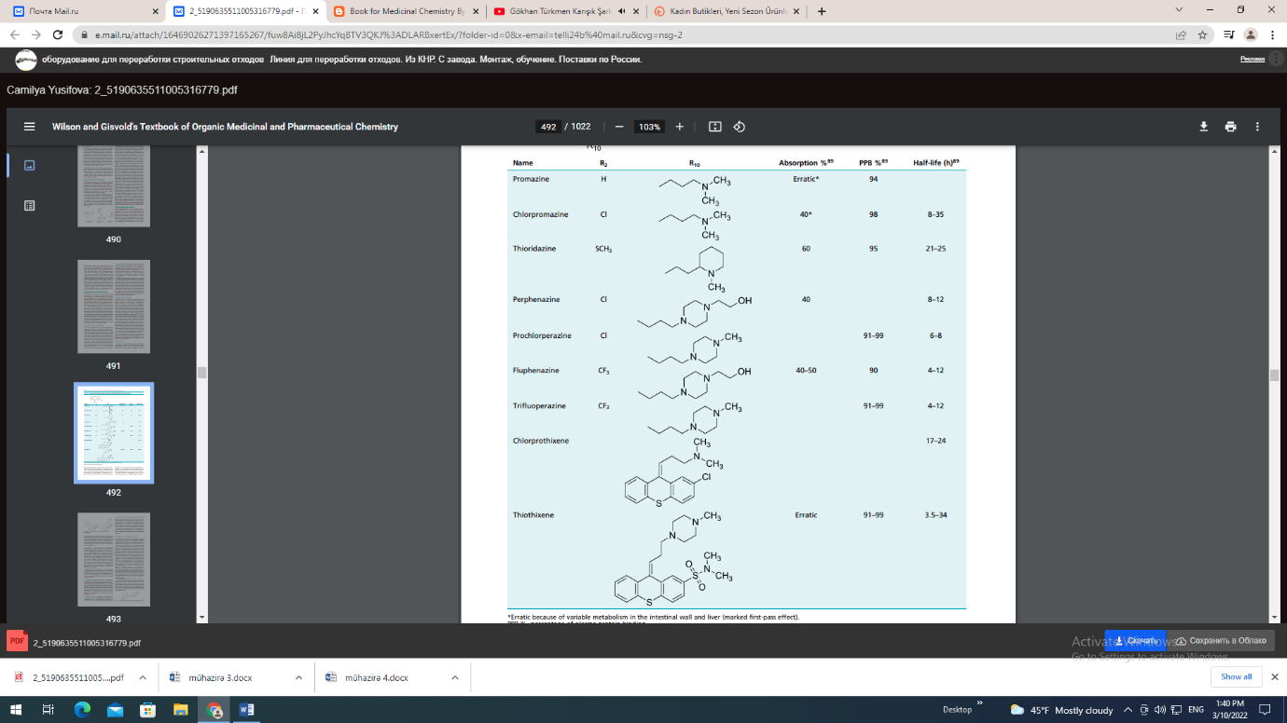

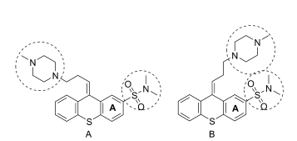
Chlorpromazine has strong anticholinergic and sedative effects and is a potent antiemetic. It is considered a low-potency neuroleptic agent and therefore the associated incidence of EPS is low. The incidence of sedative, anticholinergic, and cardiovascular side effects is high, however. It is indicated for the symptomatic relief of nausea, vomiting, hiccups, and porphyria; for preoperative sedation; and for the treatment of psychotic disorders. Thioridazine Hydrochloride, USP. Thioridazine hydrochloride, 10-[2-(1-methyl-2-piperidyl)ethyl]-2- (methylthio)phenothiazine (Mellaril), is a member of the piperidine subgroup of the phenothiazines. Thioridazine occurs as a white or slightly yellow, crystalline or micronized powder, which is odorless or has a faint odor and is practically insoluble in water and freely soluble in dehydrated alcohol (pKa 9.66). Thioridazine has relatively low tendency to produce EPS. The drug has sedative and hypotensive activity in common with chlorpromazine and less antiemetic activity. At high doses, pigmentary retinopathy has been observed. Thioridazine has similar activity toward the CYP450 family of enzymes as chlorpromazine. Thioridazine is indicated for the treatment of schizophrenic patients who fail to respond adequately to treatment with other antipsychotic drugs. Perphenazine, USP. Perphenazine, 2-[4-[3-(2-chloro10H-phenothiazin-10-yl)propyl]piperazin-1-yl]ethanol. Perphenazine is a minor substrate of CYP1A2, 2C9, 2C19, and 3A4 and a major substrate for 2D6. Perphenazine is indicated for use in the management of the manifestations of psychotic disorders and for the control of severe nausea and vomiting in adults. Trifluoperazine Hydrochloride, USP.
Trifluoperazine hydrochloride, 10-[3-(4-Methyl-1-piperazinyl) propyl-[2- (trifluoromethyl) phenothiazine dihydrochloride (Stelazine). The absorption of trifluoperazine is erratic and variable and it is widely distributed into tissues. The excretion of trifluoperazine occurs 50% via kidneys and the other 50% is through enterohepatic circulation. The metabolism and drug interactions of trifluoperazine are the same as with the other phenothiazines. Trifluoperazine does not show any specific drug interactions. Trifluoperazine is indicated for the management of schizophrenia and short-term treatment of nonpsychotic anxiety. Thiothixene, USP. Thiothixene, N,N-dimethyl-9-[3- (4-methyl-1-piperazinyl)propylidene]thioxanthene-2- sulfonamide (Navane). The absorption of thiothixene is erratic because of its high lipophilicity. Thiothixene is widely distributed into tissues and it is more than 90% bound to plasma proteins. Thiothixene has a similar metabolic pathway as the phenothiazines. Thiothixene is a major substrate of CYP1A2, and CYP1A2 inducers may decrease the levels/effects of thiothixene, whereas CYP1A2 inhibitors may increase the levels/effects of thiothixene. Thiothixene is also a weak inhibitor of CYP2D6. As with other antipsychotic agents, some patients who are resistant to previous medications have responded favorably to thiothixene. Thioxanthenes may also be of value in the management of withdrawn, apathetic schizophrenic patients..
BUTYROPHENONES AND RELATED STRUCTURES
Haloperidol was discovered by Janssen Laboratories (1958) as a byproduct while they were investigating analgesics structurally related to meperidine.73 The behavioral profile of haloperidol was found to be very similar to that of chlorpromazine, but the required dose was about 50-fold less to exert the same behavioral effect. It was rapidly studied and pursued as a new drug. Soon after, Janssen Laboratories discovered and developed droperidol, another butyrophenone analog. Conformationally, the butyrophenones can assume a conformation resembling portions of the phenothiazine molecule. The three-carbon side chain of the phenothiazines may be analogous to the three-carbon bridge that separates the amino function from the carbonyl moiety of haloperidol. Moreover, the piperidine ring would correspond to the side chain amine or piperazine of the phenothiazines. After the introduction of haloperidol and droperidol, a great number of SAR studies were carried out.92 As for the pharmacophore of the butyrophenones (Fig. 13.6), it is known that a tertiary amino group at the fourth carbon as well as the para-substituted (F is preferred) phenyl ring at the 1-position are required for D2 affinity.93,94 Possible variations on the butyrophenone group are at the piperidine moiety, in particular at the 4- position of the ring. Modifications by lengthening, shortening, or branching of the three-carbon propyl chain decrease neuroleptic activity. Replacement of the keto group also decreases D2 affinity. The tertiary amino group is usually part of an N-containing heterocycles, preferably a piperidine ring. Replacement of the six-member basic ring by smaller or larger heterocyclic rings or by noncyclic amines decreases DA affinity. Conformationally restricted butyrophenones also possess high D2 affinity. Haloperidol and droperidol are the only butyrophenones currently commercially available in the United States. Replacement of the keto group for a di-4-fluorophenylmethane moiety produced diphenylbutylpiperidines, another class of neuroleptics. Pimozide, the prototype of this group of drugs, is structurally related to droperidol and is the only member commercially available within the diphenylbutylpiperidines class.
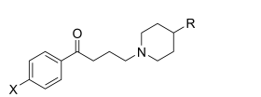
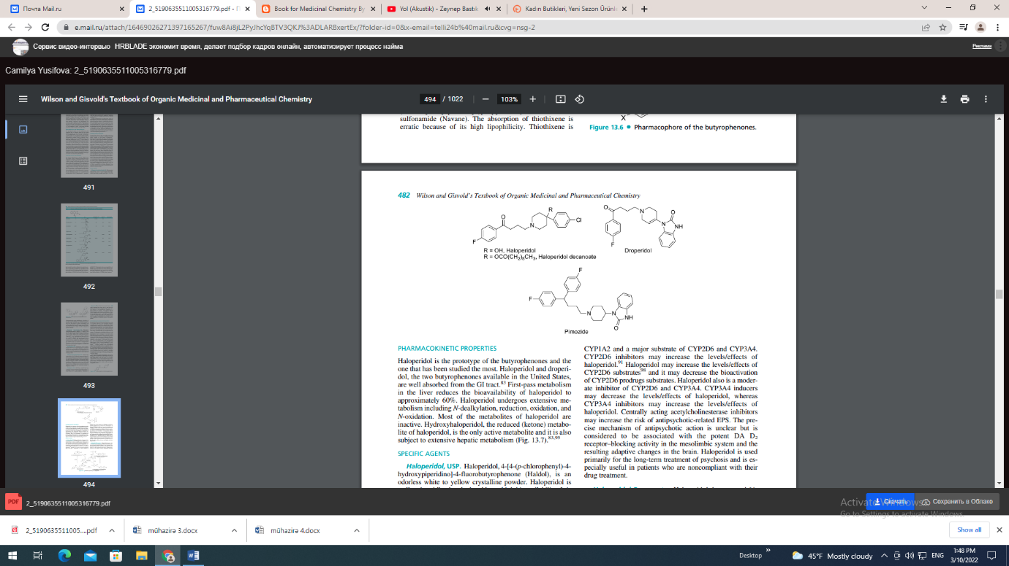

PHARMACOKINETIC PROPERTIES
Haloperidol is the prototype of the butyrophenones and the one that has been studied the most. Haloperidol and droperidol, the two butyrophenones available in the United States, are well absorbed from the GI tract.83 First-pass metabolism in the liver reduces the bioavailability of haloperidol to approximately 60%. Haloperidol undergoes extensive metabolism including N-dealkylation, reduction, oxidation, and N-oxidation. Most of the metabolites of haloperidol are inactive. Hydroxyhaloperidol, the reduced (ketone) metabolite of haloperidol, is the only active metabolite and it is also subject to extensive hepatic metabolism (Fig. 13.7).83,95 SPECIFIC AGENTS Haloperidol, USP. Haloperidol, 4-[4-(p-chlorophenyl)-4- hydroxypiperidino]-4-fluorobutyrophenone (Haldol), is an odorless white to yellow crystalline powder. Haloperidol is well and rapidly absorbed and has a high bioavailability. It is more than 90% bound to plasma proteins. Haloperidol is excreted slowly in the urine and feces. About 30% of a dose is excreted in urine and about 20% of a dose in feces via biliary elimination,96 and only 1% of a dose is excreted as unchanged drug in the urine.97 Haloperidol is a minor substrate of CYP1A2 and a major substrate of CYP2D6 and CYP3A4. CYP2D6 inhibitors may increase the levels/effects of haloperidol.91 Haloperidol may increase the levels/effects of CYP2D6 substrates98 and it may decrease the bioactivation of CYP2D6 prodrugs substrates. Haloperidol also is a moderate inhibitor of CYP2D6 and CYP3A4. CYP3A4 inducers may decrease the levels/effects of haloperidol, whereas CYP3A4 inhibitors may increase the levels/effects of haloperidol. Centrally acting acetylcholinesterase inhibitors may increase the risk of antipsychotic-related EPS. The precise mechanism of antipsychotic action is unclear but is considered to be associated with the potent DA D2 receptor–blocking activity in the mesolimbic system and the resulting adaptive changes in the brain. Haloperidol is used primarily for the long-term treatment of psychosis and is especially useful in patients who are noncompliant with their drug treatment. Haloperidol Decanoate. Haloperidol decanoate, 4-[4- (4-chlorophenyl)-4-hydroxypiperidino]-4-fluorobutyrophenone decanoate (Haldol Decanoate), is the decanoate ester (prodrug) of haloperidol. Peak plasma concentrations occur within 3 to 9 days and then decrease slowly.
Haloperidol decanoate has no intrinsic activity. Haloperidol decanoate undergoes hydrolysis by plasma and/or tissue esterases to form haloperidol and decanoic acid, subsequently; haloperidol is metabolized in the liver. The pharmacological effects are those of haloperidol, which is released by bioconversion. Haloperidol decanoate is indicated for the treatment of longterm maintenance in schizophrenia, psychoses especially paranoid, and other mental and behavioral problems. Droperidol, USP. Droperidol, 1-1-[3-(p-fluorobenzoyl) propyl]-1,2,[3,6-tetrahydro-4-pyridyl]-2-benzimidazolinone (Inapsine). Centrally acting acetylcholinesterase inhibitors may increase the risk of antipsychotic-related EPS. CNS depressants may produce additive sedative effects (benzodiazepines, barbiturates, antipsychotics, ethanol, opiates, and other sedative medications). Droperidol in combination with certain forms of inhalation anesthetics may produce peripheral vasodilatation and hypotension. Metoclopramide may increase the risk of EPS produced by droperidol. Pimozide, USP. Pimozide, 1-[1-[4,4-bis(p-fluorophenyl)butyl]-4-piperidyl]-2-benzimidazolinone (Orap), is a white to creamy white solid (pKa 9.42). Pimozide is 50% absorbed after oral administration. It is metabolized by CYP450 enzymes, in particular the CYP3A4 and CYP1A2 isozymes, to inactive metabolites. Pimozide is excreted in the urine and to a lesser extent in the feces. Toxic effects may be produced with pimozide in the presence of inducers or inhibitors of CYP3A4 and CYP1A2. Pimozide is also a strong inhibitor of CYP2D6 without appearing to be an important substrate of this isoform.99 The use of pimozide in the United States is small, but it is a critical drug for many patients with Gilles de la Tourette disorder who cannot tolerate haloperidol. Atypical Antipsychotic Agents Atypical antipsychotics (also known as second-generations) include drugs such as clozapine, olanzapine, quetiapine, risperidone, aripiprazole, and ziprasidone. With the development of the first atypical antipsychotic, clozapine, a clear division in treatment outcomes was observed. Atypical antipsychotics have generally shown to provide a greater reduction in both the positive and negative symptoms of schizophrenia, as well as an improvement in cognitive function. Thus, atypical antipsychotics are currently considered to be the first line of treatment for individuals with schizophrenia. Affinity for 5-HT2A receptors is a feature of several of the recently developed atypical antipsychotics. Many researchers believe that D2 receptor antagonism, coupled with 5-HT2A receptor antagonism, is responsible for the differentiation of effects observed with atypical antipsychotics. Inhibitory 5-HT neurons terminate on presynaptic DA neurons in the striatum. Thus, antagonism of presynaptic 5- HT2A receptors leads to an increase in DA release. This increase in DA release is thought to attenuate D2 blockade caused by antipsychotics. The decreased EPS associated with some of the atypical antipsychotics has also been suggested to be caused by 5-HT2A receptor blockade.100 Nevertheless, high 5-HT2A receptor occupancy does not ensure that an antipsychotic will exhibit an atypical profile. Even at 80% to 90% 5-HT2A receptor occupancy, no antipsychotic effect is observed unless D2 receptor occupancy exceeds the 65% threshold.101,102 Other theories regarding the mechanisms of action of atypical antipsychotics have also been suggested. Kapur and Seeman101 proposed that a low occupancy of D2 receptors is sufficient to account for an atypical action. These investigators have suggested that a fast dissociation rate from D2 receptors allows for DA neurotransmission that is more physiological. Yet, this theory has been questioned because several typical antipsychotics dissociate at similar rates as atypical agents.103 The atypical profile of clozapine was initially suggested to be related to its high affinity for D4 receptors; however, classical antipsychotics such as chlorpromazine and haloperidol also bind with high affinity at the D4 receptor (Table 13.2). Additionally, the atypical antipsychotic, quetiapine, has no appreciable affinity for the D4 receptor. Thus, it seems that antagonism at the D4 receptor cannot explain the unique profile of atypical antipsychotics.104,105 In the end, no single theory to date has been able to globally define and/or differentiate the actions of antipsychotics. This is as much caused by the complexity of the disease and interpretation of respective drug-mediated behavioral effects, as it is to determining the actual mechanism of action of any individual drug. SPECIFIC AGENTS Clozapine. Clozapine, 8-chloro-11-(4-methyl-1-piperazinyl) 5H-dibenzo[b,e] [1,4] diazepine (Clozaril), is a yellow crystalline powder that is only slightly soluble in water. With the introduction of clozapine, a different pharmacological profile was observed compared with the classical antipsychotics.106 Unlike typical antipsychotics, clozapine is largely devoid of EPS. The lack of EPS with this compound was postulated to be caused by its preferential binding to mesolimbic rather than striatal DA receptors.107 Furthermore, clozapine was shown to exhibit potent affinity for 5-HT2A receptors.108 When administered at a dose of 100 mg twice a day (bid [L. bis in die]), an average steady state plasma concentration of 319 ng/mL resulted at an average of 2.5 hours after administration. Because food does not apparently affect absorption, clozapine may be given with or without food. The compound is 97% bound to plasma proteins; however, interactions with other drugs have not been fully investigated.23 Clozapine is extensively metabolized after absorption with 50% of an administered dose excreted in the urine and 30% in the feces. Clozapine is metabolized to two major metabolites by N-oxidation and N-demethylation. Clozapine N-oxide (CZNO) is thought to be formed by the action of CYP3A4 and flavin monooxygenase 3 (FMO3), whereas N-desmethylclozapine (DMCZ) appears to result by the action of CYP3A4 and CYP1A2 (Fig. 13.8).109 Clozapine also binds with high affinity at M1 and M4 muscarinic receptors in the limbic area of the brain.104 Whether affinity for muscarinic receptors contributes to the atypical profile for clozapine has not been established.103 DMCZ shows partial agonism at D2 and D3 receptors and exhibits a distinctly different pharmacological profile compared with clozapine and other atypical antipsychotics. Unlike clozapine, which is a potent M1 muscarinic antagonist, DMCZ is a potent M1 agonist. Agonism at muscarinic receptors has been proposed to be useful for impaired cognition in schizophrenia. Burnstein et al.110 found that DMCZ acted as a partial agonist at DA D2 and D3 receptors. These investigators suggested that the low incidence of EPS associated with clozapine may be caused by the partial agonism of DMCZ at D2 and D3 receptors. Thus, DMCZ may be of interest as an atypical antipsychotic with an improved side effect profile compared with clozapine. Although clozapine demonstrates a favorable pharmacological profile compared with typical antipsychotics, its use is restricted by a relatively high incidence of agranulocytosis. The exact mechanism for the cause of agranulocytosis has not been confirmed, but a highly reactive nitrenium ion that is formed by the action of hepatic enzymes appears to be involved.111 The mean elimination half-life of clozapine following a single 75-mg dose is 8 hours. Because of several adverse effects, clozapine is only used in refractory cases of schizophrenia. Individuals with a history of seizures or predisposed to seizures should be cautioned when taking clozapine. Similar to other atypical antipsychotic agents, clozapine causes an increased risk of mortality in elderly individuals with dementia-related psychoses.
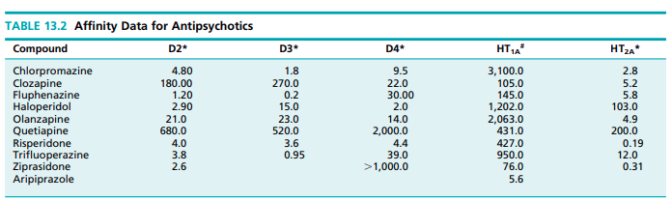
Olanzapine. Olanzapine, 2-methyl-4-(4-methyl-1-piperazinyl)-10H-thieno [2,3-b][1,5] benzodiazepine (Zyprexa), is a yellow crystalline solid that is essentially insoluble in water. Olanzapine orally disintegrating tablets (Zyprexa Zydis) is a solid dosage form that immediately disintegrates when exposed to saliva. This product is useful for elderly patients who have difficulty in swallowing. An injectable form, olanzapine for injection (Zyprexa IM), is indicated for agitation associated with schizophrenia or bipolar I mania. Olanzapine is combined with fluoxetine (Symbyax) for use in depression that is associated with bipolar I disorder. Peak concentrations of oral olanzapine are reached at 6 hours after oral administration, and absorption of the compound is not affected by food.23 Olanzapine is 93% bound to plasma proteins, and its mean half-life is 27 hours.112,113 Olanzapine undergoes extensive first-pass metabolism, and about 40% of an oral dose is metabolized prior to reaching the systemic circulation. The major metabolite of olanzapine in human subjects is the 10- N-glucuronide. Other human metabolites that have identified include the N-desmethyl, the N-oxide, and the 2-hydroxymethyl metabolites (Fig. 13.9). The N-desmethyl and the 2- hydroxymethyl metabolites are products of CYP1A2 and CYP2D6 action, respectively.112,113 Olanzapine binds with high affinity at DA D2, 5-HT2A, 5-HT2C, 5-HT6, 1, and H1 histamine receptors. The effects of olanzapine for the treatment of schizophrenia are presumably mediated through antagonism at D2 and 5-HT2A receptors.23,112,113 The use of olanzapine in acute mania that is associated with bipolar I disorder is thought to be mediated by antagonism at D2 and other monamine receptors. Additionally, olanzapine is postulated to produce its mood stabilizing and antidepressant effects through 5-HT2A receptor blockade and increased cortical DA and NE concentrations.114 Several studies have investigated the effect of olanzapine-induced weight gain and new-onset type 2 diabetes.115,116 In a comparison study with risperidone, olanzapine was shown to have a greater risk of producing dyslipidemia and type 2 diabetes.105,116 Quetiapine. Quetiapine, 2-[2-(4-dibenzo[b,f][1,4]thiazepin-11-yl-1-piperazinyl)ethoxy]-ethanol fumarate (2:1, salt) (Seroquel), is a white to off-white crystalline powder that is moderately water soluble. Quetiapine is rapidly absorbed, and peak plasma levels occur 1 to 2 hours after administration. Food does not appreciably affect the absorption of quetiapine. The compound is 83% bound to plasma proteins and it has a mean elimination half-life of 7 hours. Administration of a single dose of 14C-quetiapine showed that only 1% of the drug was excreted unchanged, with 73% excreted into the urine and approximately 30% excreted in the feces.23 Numerous metabolites of quetiapine are known, and the sulfoxide metabolite represents the major metabolite present in plasma (Fig. 13.10). This metabolite is pharmacologically inactive. The remaining metabolites represent only 5% of the total radioactivity found in plasma. The 7-hydroxy and the 7-hydroxy-N-desalkyl are active metabolites, but because of their low concentrations in plasma are not thought to contribute to the overall effects of quetiapine.107,117 In human liver microsomes, four primary metabolites of quetiapine are formed. These include quetiapine sulfoxide, 7-hydroxyquetiapine, and the N- and O-desalkylated metabolites (Fig. 13.10). This study showed that CYP3A4 is the major isoform of P450 responsible for quetiapine metabolism. CYP3A4 inducers (carbamazepine) or CYP3A4 inhibitors (ketoconazole) can either decrease or increase plasma levels of quetiapine.
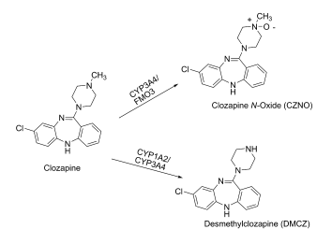
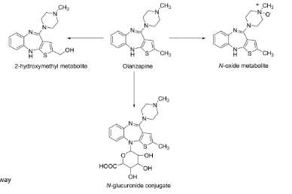
In human liver microsomes, four primary metabolites of quetiapine are formed. These include quetiapine sulfoxide, 7-hydroxyquetiapine, and the N- and O-desalkylated metabolites (Fig. 13.10). This study showed that CYP3A4 is the major isoform of P450 responsible for quetiapine metabolism. CYP3A4 inducers (carbamazepine) or CYP3A4 inhibitors (ketoconazole) can either decrease or increase plasma levels of quetiapine.118 Common side effects associated with quetiapine therapy are orthostatic hypotension and somnolence. These effects are presumably caused by -adrenergic and histamine H1 receptor blockade, respectively. As with other atypical antipsychotics, patients treated with quetiapine should be monitored for hyperglycemic symptoms. Also, children and adolescents with major depressive disorder may experience an increase in their depression or suicidal tendencies.23,107 Quetiapine binds with high affinity at 1, 2, H1, and 5-HT2A receptors but has much lower affinity for D2 and 5-HT1A receptors. The action of quetiapine at D2 and 5-HT2A receptors is that of an antagonist, whereas it shows agonist effects at 5-HT1A receptors.119,120 Quetiapine dissociates rapidly from D2 receptors, and this leads to lower D2 receptor occupancy compared with typical antipsychotics such as chlorpromazine.121 This finding may explain the lack of EPS associated with quetiapine.107 Risperidone. Risperidone, 3-[2-[4-(6-fluoro-1,2- benzisoxazol-3-yl)-1-piperidinyl]ethyl-6,7,8,9-tetrahydro-2- methyl-4H-pyrido[1,2]pyrimidin-4-one (Risperdal), is a white to slightly beige powder that is essentially insoluble in water. Risperidone is also available as a 1-mg/mL oral solution and as orally disintegrating tablets (Risperdal M-Tab). Risperidone is well absorbed, and peak levels occur about 1 hour after administration. The absorption of risperidone is not affected by food. Risperidone is about 90% bound to albumin and 1-acid glycoprotein, whereas its metabolite 9-hydroxyrisperidone is bound about 77%.23 Risperidone is primarily metabolized in humans to the active metabolite 9-hydroxyrisperidone (Fig. 13.11). Although CYP2D6 was thought to be the major P450 isoform in the formation of the 9-hydroxy metabolite, a recent report suggests that CYP3A4 is involved.121 The potent CYP3A4 inducer, rifampin, was shown to significantly reduce plasma concentrations of risperidone,122 whereas ketoconazole, a CYP3A4 inhibitor, decreased the formation of the 9-hydroxy metabolite.123 The metabolism of risperidone appears to be stereoselective. In human microsomes, the CYP2D6 inhibitor, quinidine, strongly inhibited the formation of ()-9-hydroxyrisperidone, whereas the CYP3A4 inhibitor, ketoconazole, inhibited the formation of ()-9-hydroxyrisperidone.124 Individuals concurrently on risperidone and other medications should be carefully monitored because impaired CYP2D6 activity could increase the risk for drug interactions.125,126 Renal excretion is the main route of elimination for risperidone and its metabolites. The mean half-life of risperidone is 3 hours in extensive metabolizers and 21 hours in poor metabolizers, respectively. The elimination half-life for the 9-hydroxy metabolite is similar to risperidone in extensive and poor metabolizers, with an overall elimination half-life of about 20 hours.23 The major side effects associated with risperidone therapy are orthostatic hypotension, dose-related hyperprolactinemia, mild weight gain, EPS, and insomnia.127 At higher doses (6 mg/day), risperidone is the atypical antipsychotic that most closely resembles conventional agents. A PET study in a group of individuals with schizophrenia showed that D2 receptor occupancy was dose dependent. If the dose was increased such that D2 receptor occupancy was 79% to 85%, the majority of patients developed EPS.126 Risperidone is associated with increased mortality in elderly patients with dementia-related psychosis and is not recommended for these individuals.23 Risperidone binds with high affinity at 5-HT2A, 5-HT7, D2, 1, 2, and H1 receptors. The antipsychotic action of risperidone has been proposed to be the result of D2 and 5-HT2A antagonism.23,107 Risperidone is effective in treating the positive and negative symptoms of schizophrenia and as adjunct therapy in bipolar mania.127 The U.S. Food and Drug Administration (FDA) granted approval of risperidone orally disintegrating tablets in October 2006 for the treatment of irritability in autistic children and adolescents.23 Paliperidone. Paliperidone, ()-3-[2-[4-(6-fluoro-1,2- benzisoxazol-3-yl)-1-piperidinyl]ethyl]-6,7,8,9-tetrahydro-9- hydroxy-2-methyl-4H-pyrido[1,2-a]pyrimidin-4-one (Invega), is essentially insoluble in water and is available as extended-release tablets. Paliperidone is delivered at a constant rate using an osmotic drug release device (Osmotic Release Oral Systems [OROS]). The absolute bioavailability of paliperidone is 28%, and studies in healthy subjects on a high-fat, high-calorie meal showed an increase in AUC. Paliperidone is 74% bound to plasma proteins. After a single, 1-mg dose of 14C-paliperidone, 59% of the dose was excreted in the urine as unchanged drug, and 32% of the dose was recovered as metabolites. Most of the drug (80%) is excreted by the kidneys. Paliperidone is metabolized by dealkylation, hydroxylation, dehydrogenation, and scission of the benzoxazole ring. None of these metabolic pathways account for more than 10% of the dose. The terminal elimination half-life of paliperidone is 23 hours.23 Aripiprazole. Aripiprazole, (7-[4-[4-(2,3-dichlorophenyl)-1-piperazinyl]butoxy]-3,4-dihydro-2(1H)-quinolone, is an atypical antipsychotic that is available in tablets (Abilify), orally disintegrating tablets (Abilify Discmelt), and a 1-mg/mL oral solution. Unlike the other atypical antipsychotics, aripiprazole exhibits partial agonist activity at D2, D3, D4, and 5-HT1A receptors, and antagonist action at 5-HT2A receptors. Although aripiprazole exhibits a low incidence of EPS, the compound occupies about 95% of striatal D2 receptors at therapeutic doses. Additionally, aripiprazole does not have a fast rate of dissociation from D2 receptors. Although the mechanism of action of this compound remains to be elucidated, the atypical profile for aripiprazole may be related to its action at other monoamine receptors.105,128 The compound is well absorbed with peak plasma levels occurring 3 to 5 hours after oral administration. Food does not affect absorption of aripiprazole. Aripiprazole is extensively metabolized in the liver by the action of CYP2D6 and CYP3A4. The primary metabolite in humans is dehydroaripiprazole (Fig. 13.12). This metabolite represents about 40% of aripiprazole at steady state.23 In the presence of CYP3A4 and CYP2D6 inhibitors or inducers, dosage adjustments of aripiprazole may be required. The mean elimination half-lives in extensive and poor metabolizers are 75 hours and 146 hours, respectively.23 The major adverse effects of aripiprazole are headache, anxiety, and insomnia.129 Similar to other atypical antipsychotics, aripiprazole shows an increased risk in mortality in elderly patients with dementia-related psychosis.23 Aripiprazole demonstrates a different pharmacological profile from all other atypical antipsychotics. The compound exhibits partial agonist activity at 5-HT1A receptors and antagonist action at 5-HT2A receptors. The partial agonism at 5-HT1A may contribute to the effects of aripiprazole against the negative symptoms of schizophrenia.130 Unlike other antipsychotics, aripiprazole acts as a partial agonist at D2 receptors. Additionally, the major metabolite, dehydroaripiprazole, shows similar pharmacological properties as aripiprazole, and it also acts as a partial agonist at D2 receptors.131 It has been suggested that a partial D2 agonist will exhibit functional agonist activity in areas of the brain (mesocortical pathway) that have low DA levels, whereas a D2 partial agonist can function as an antagonist in areas of the brain (mesolimbic pathway) where DA levels are high. Thus, positive symptoms of schizophrenia are reduced without significant EPS.132 Aripiprazole is indicated for schizophrenia and for acute mania that is associated with bipolar I disorder.
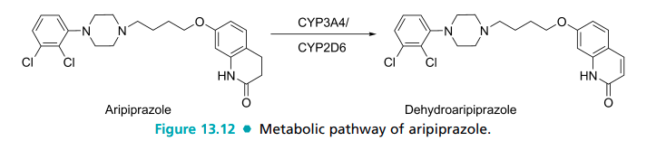

Ziprasidone. Ziprasidone, 5-[2-[4-(1,2-benzisothiazol3-yl)-1-piperazinyl]ethyl]-6-chloro-1,3-dihydro-2H-indol-2- one, is available as the hydrochloride monohydrate for oral administration (Geodon) and as the mesylate trihydrate salt for intramuscular (IM) injection. The compound is well absorbed with peak plasma levels occurring at 6 to 8 hours after oral administration. The oral absorption is enhanced approximately twofold in the presence of food. Ziprasidone is bound about 99% to plasma proteins, primarily to albumin and 1-acid glycoprotein. Ziprasidone is not displaced in the presence of two highly protein bound drugs, warfarin and propranolol. Ziprasidone is extensively metabolized with only about 5 % of the drug excreted unchanged.23 In humans, two major pathways are responsible for the metabolism of ziprasidone: (a) oxidation by CYP3A4 (one third) and (b) reduction by aldehyde oxidase (two thirds).133,134 The combined action of these metabolic pathways leads to four major circulating metabolites: benzisothiazole piperazine sulfoxide (BITP-sulfoxide), benzisothiazole piperazine sulfone (BITPsulfone), ziprasidone sulfoxide, and S-methyldihydroziprasidone (Fig. 13.13).
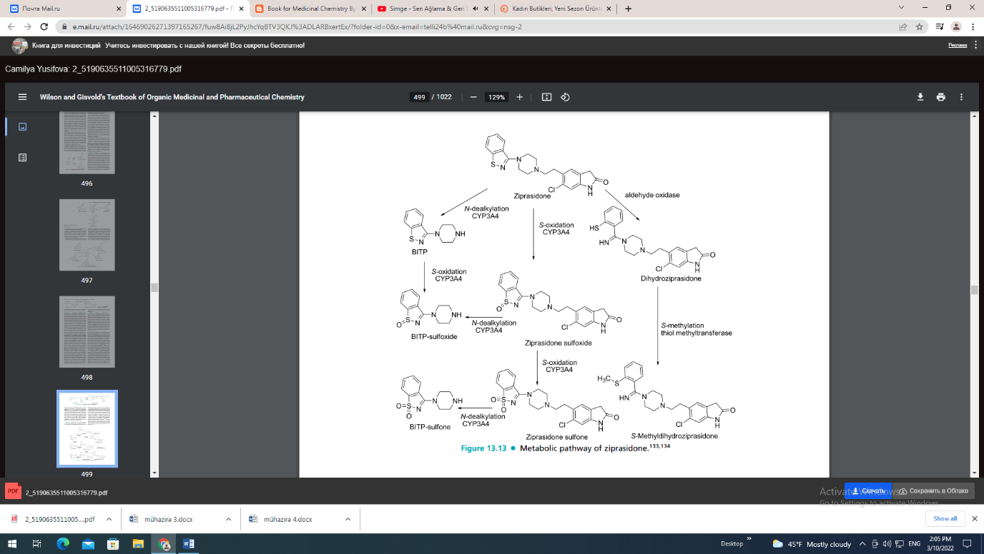
Multidrug therapy involving ziprasidone does not appear to be a serious concern, because the reductive activity of aldehyde oxidase is not affected by other drugs.134 The elimination half-life of ziprasidone is 4 hours with about 20% of the drug excreted in urine and 66% eliminated in the feces.23,107 Ziprasidone has a low incidence of sedation, EPS, and postural hypotension. Unlike other atypical antipsychotics, ziprasidone does not cause weight gain or elevated glucose levels. Ziprasidone has been shown to cause a mild-to-moderate increase in the QTc interval.134 Prolongation of the QTc interval in some other drugs is associated with potentially lifethreatening ventricular arrhythmias and sudden death. As with other atypical antipsychotic agents, ziprasidone can increase the risk of mortality in elderly patients with dementia-related psychosis and is not indicated in these individuals.23 Ziprasidone binds with high affinity at D2, D3, 5-HT1A, 5- HT1D, 5-HT2A, 5-HT2C, and 1-receptors. The compound acts as an agonist at 5-HT1A receptors and as an antagonist at D2 and 5-HT2A receptors. Ziprasidone also inhibits synaptic uptake of serotonin and norepinephrine. Thus, it has been postulated that ziprasidone has potential use as an anxiolytic and an antidepressant.107,135 Ziprasidone is indicated for schizophrenia and acute mania that is associated with bipolar disorder, whereas the injectable form of ziprasidone is indicated for the treatment of acute agitation in schizophrenic patients.23 FUTURE DIRECTIONS DA has long been linked with PD and schizophrenia in a unique and multifaceted relationship. Although this close association ensures that DA and the dopaminergic systems will remain a primary focus for the treatment of both PD and schizophrenia, other avenues of therapy are on the horizon. A focus on neuroprotective agents for the treatment of PD may provide a more efficacious approach than DA symptomology-based therapies. Such treatments would target the mechanisms involved in the pathogenesis of the disease. A promising antioxidant, coenzyme Q10 (ubiquinone), has been proposed to slow down functional decline.136 Based on findings that mitochondrial dysregulation and oxidative damage may play a role in the loss of nigral neurons, it is hypothesized that coenzyme Q10 could be an effective neuroprotectant.136,137 Inhibitors of glutamate, anti-inflammatory, and antiapoptotic drugs have also been proposed as PD neuroprotectants,138,139 although currently there is a lack of clinical verification. Yet, another approach is the use of gene therapy, using a glial cell line-derived neurotrophic factor to slow neurodegeneration in PD.18,140,141 New approaches are also being explored in terms of schizophrenia treatment. Over the past decade, a dysfunction of glutaminergic neurons has been suggested to contribute to the pathophysiology of schizophrenia. This theory is supported by the fact that a noncompetitive inhibitor at NMDA receptors (a subtype of glutamate receptors) produces positive and negative symptoms of schizophrenia in normal subjects. Compounds that target the NMDA receptor may offer an alternative treatment for schizophrenia.142 Ultimately, future strategies for the pharmacological treatment of PD and schizophrenia will likely evolve into a combination DA and non-DA approaches, appropriately tailored to each patients needs.

Phetothiazine derivatives
Phenothiazine itself has a helminthicide and local anaesthetic activity.

S
N
H
1
2
3
4
5
6
7
8
9
1
0
The general formula of phenothiazine derivatives is:

S
N
R
R
.
H
C
l
Many potentially useful phenothiazine derivatives have been synthesized and pharmacologically evaluated. Consequently, there is a large body of information permitting accurate statements about the structural features associated with activity. The best position for substitution is the 2-position. Activity increases (with some exceptions) as the electron-withdrawing ability of the substituent increases.
Depending on a substituent of nitrogen (10) atom phenothiazines
have various pharmacological actions: 10-alkylderivatives (chloropro-
mazine (aminazinum), promethazine (diprazinum), promazine, perphenazine (aethaperazinum)) are used as antipsychotic and antihista mine substances, 10-acylderivatives (aethmozinum) are effective for treating of cardiac diseases.
Chloropromazine Hydrochloride
(Aminazinum), Ph. Eur.
S
N
C
H
2
C
l
.
H
C
l
C
H
2
C
H
2
N
C
H
3
C
H
3
3-(2-Choloro-10/T-phenothiazin-10-yl)-N,N-dimethylpropan-1-amine hydrochloride
Preparation. Chlorpromazine hydrochloride (aminazinum) is synthesized by the flowing scheme:
H
N
S
+
C
l
C
H
2
C
H
2
C
H
2
N
C
H
3
C
H
3
+

N
a
N
H
2
l
C
c
h
l
o
r
o
p
h
e
n
o
t
h
i
a
z
i
n
e
3
-
d
i
m
e
t
h
y
l
a
m
i
n
o
p
r
o
p
y
l
c
h
l
o
r
i
d
e
s
o
d
i
u
m
a
m
i
d
e

C
H
3
N
S
l
C
C
H
3
C
H
2
C
H
2
C
H
2
N
H
C
l
c
h
l
o
r
o
p
r
o
m
a
z
i
n
e
C
H
3
N
S
l
C
C
H
3
C
H
2
C
H
2
C
H
2
N
H
C
l
.
chloropromazine hydrochloride
Properties. A white or almost white, crystalline powder, very soluble in water, freely soluble in alcohol and practically insoluble in ether. It decomposes on the exposure to air and light.
Identification. 1. UV-spectrum. Prepare the solution protected from light and measure the absorbances immediately.
2. IR-spectrum.
3. Thin-layer chromatography (the solution for detection — 10% sulphtıric acid in ethanol).
4. The reactions of chlorides.
Non-Pharmacopoeial reactions: a) with oxidizers (concentrated H₂S0₄, bromine water, HN0₃, FeCl₃ and others):

R
R
N
S
O
R
R
N
O
O
S
R
R
N
S
O
O
— the reaction with bromine water (more specific). The substance gives a transparent red colour of the solution. The probable structure of the product obtained is:

R
+
N
S
(
B
r

B
r
2
)
-
.
— the reaction with concentrated H₂S0₄ — a red colour appears;
- reactions with alkaloid reagents (due to tertiary nitrogen) — the substance forms precipitates;
- after the interaction with NaOH the base of the substance ex- amined is obtained;
- sulphur is detected after mineralization with KN0₃ and K^COj by the forming of a precipitate with BaCl₂.
Assay. 1. Alkalimetry in the medium of alcohol and in the pre- sence of 0.01 M hydrochloric acid. Titrate with 0.1 M sodium hydro- xide solution determining the end-point potentiometrically. Read the volume added between the points of inflexion; 5=1.
- Non-aqueous titration. Titrate with perchloric acid in the pre- sence of (CH₃COO)₂Hg using methyl orange as an indicator in the acetone medium and crystal violet in the medium of the anhydrous acetic acid; 5=1.
- Alkalimetry in the presence of chloroform, 5=1.
- Determination of nitrogen by sulphuric acid digestion (the Kjel- dahl’s method).
- Cerimetry.
- Iodometry.
- Iodine-chlorimetry.
- Spectrophotometry.
- Photocolorimetry.
Usage. Antipsychotic, antiemetic.
Storage. In an airtight Container protected from light.

Promethazine Hydrochloride, Ph. Eur.
(Diprazinum)

N
S
C
H
2
C
H
N
C
H
3
H
C
l
C
H
3
C
H
3
.
(2 RS)-N. N - Dimethyl-1 -(1O/Tphenothiazin-10-yl)propan-2-amine
hydrochloride
Properties. A white or faintly yellowish, crystalline powder, very oluble in water, freely soluble in alcohol and in methylene chloride. ı melts at about 222 °C with decomposition.
Identification. 1. IR-spectrum.
- Thin-layer chromatography (see Chloropromazıne).
- Dissolve the substance in water, add nitric acid dropwise. A precipitate is formed; it rapidly dissolves giving a red solution, be-corning orange and then yellow. Heat to boiling. The solution becomes orange and an orange-red precipitate is formed.
- The reactions of chlorides.,
Non-Pharmacopoeial reactions (see Chloropromazine): a) with bromine water — a turbid dark-red solution with a precipitate;
- with the concentrated H₂S0₄ — a red or orange-red colouring;
- reactions with alkaloid reagents (due to tertiary nitrogen) — the substance forms precipitates;
- after the interaction with NaOH the base of the substance ex-amined is obtaıned;
- sulphur is detected äfter mineralization with KN0₃ and K₂ CO₃ by forming a precipitate with BaCl₂.
Assay. Alkalimetry in alcohol and in the presence of 0.1 M hydrochloric acid. itrate with 0.1 M sodium hydroxide determining the and-point potentiometrically; s— 1.
Usage. Antihistaminic, neuroleptic.
Storage. In an airtight Container protected from light.

Promazine Hydrochloride, Ph. Eur.
(Propazinum)

N
S
.
H
C
l
(
C
H
2
)
3
N
(
C
H
3
)
2
3 - (10 H- Phenothiazin-10 -yl) - N ,N -dimethylpropan- 1-arnıne
hydrochloride
Properties. A white or almost white, crystalline powder, slightly hygroscopic, very soluble in water, in alcohol and in methylene chlo- ride. It melts at about 179 °C.
Identification. 1. IR-spectrum.
- Thin-layer chromatography (see Chloropromazine).
- Dissolve the substance in sulphuric acid and allow it to stand for 5 min — an orange colour is produced.
- The reactions of chlorides.
Non-Pharmacopoeial reactions: a) with bromine water — a trans- parent brown-red colouring appears;
- reactions with alkaloid reagents (due to tertiary nitrogen) — the substance forms precıpitates;
- after the interaction with NaOH the base of the substance examined is obtained;
- sulphur is detected after mineralisation with KN0₃ and K₂C0₃ by forming a precipitate with BaCl₂.
Assay. Alkalimetry in alcohol and in the presence of 0.1 M hydro- chloric acid. Titrate with 0.1 M sodium hydroxide determining the end-point potentiometrically; s=1.
Usage. Antihistaminic, neuroleptic.
Storage. In an airtight Container protected from light.

Perphenazine
(Aethaperazinum), Ph.Eur.
N
S
(
C
H
2
)
3
C
l
N
N
(
C
H
2
)
2
O
H
2-[4-[3-(2-Chk>rophenothiazin- 10-yl)propyl)piperazin-l-yl]ethanol
- The solution gives the reactions of chlorides.
Assay. Alkalimetry in aleohol and'in the presence of 0.1 M hydro- chloric acid. Titrate with 0.1 M sodium hydroxide determining the end-point potentiometrically; s = 1/2.
Usage. Antihistaminic, neuroleptic.
Storage. In an airtight Container protected from light.

DERIVATIVES OF BENZODİAZEPİNE
Benzodiazepine is a heterocyclic system, includes nuclei of benzene and 7-membered heteroeyele — 1,4-diazepine:
N
N
H
1
2
3
4
5
6
7

8

9

The electron oetet of azepines is less delocalizated than the benzene sextet; so that azepines would be expected to have üttle aromatic character and show high reactivity.
The presence of an electron-attracting substituçnt at position 7 is required for activity, and the more electron attractipg it is, the higher the activity is. Positions 6, 8, and 9 should not be substituted.
Alkyl substitution at the 3-position decreases activity, whereas substitution with a hydroxy does not. The presence or absence of the 3-hydroxyl is important pharmacokinetically. Compounds without the hydroxyl are nonpolar, have long half-lives and undergo hepatic oxidation. Compounds with the hydroxyl are much more polar and are readily converted to the excreted glucu_ronide (see the overall metabolic relationship seheme). The 2-carbonyl funetion is optimal for activity, as is the nitrögen atom at position 1. The N-substituent should be small.
1,4-benzodiazepines have weak-basic properties due to the nitrogen atom (4). Compounds with the lactam group — NH—CO— have weak-acidic properties and can form salts with alkaline metals (amphoteric compounds).
Benzodiazepines and benzodiazepine-like drugs bind to a benzo-diazepine recognition site or benzodiazepine receptor.
Medicinal substances, derivatives of benzodiazepine, are used as tranquillisers (have a sedative effect).

N
S
.
2
H
C
l
(
C
H
2
)
3
C
F
3
N
N
C
H
3

C
3
H
N
N
H
2
.
S
C
H
3
C
H
2
C
H
2
O
H
N
B
r

H
B
r

1
/

H
2
O
2
-
.
N
+

+
C
3
H
N
N
H
2
N
S
C
H
3
C
H
2
C
H
2
O
H
N
B
r

H
B
r

+

C
H
3
C
O
O
H
-
.
N
2
H
C
l
O
4

+

2
H
g
(
C
H
3
C
O
O
)
2
H
C
O
O
H
;
+
C
3
H
N
N
H
2
.
S
C
H
3
C
H
2
C
H
2
O
H
N
C
l
O
4
-
H
C
l
O
4

+

H
g
B
r
2

+

2
C
H
C
O
O
H

+
C
3
H
N
N
H
2
N
S
C
H
3
C
H
2
C
H
2
O
H
N
B
r

H
B
r

+

N
a
B
r

+

H
2
O
-
.
N

N
a
O
H
-
+
C
3
H
N
N
H
2
+
S
C
H
3
C
H
2
C
H
2
O
H
N
B
r

+
C
3
H
N
N
H
2
N
S
C
H
3
C
H
2
C
H
2
O
H
N
B
r

N
a
H
B
r

+

N
a
N
O
3

+

2
A
g
B
r
-
+
N
N
O
-
+
C
3
H
N
N
H
2
+
S
C
H
3
C
H
2
C
H
2
O
H
N
2
A
g
N
O
3

3
A
g
N
O
3

+

F
e
(
S
C
N
)
3

3
A
g
S
C
N

+

F
e
(
N
O
3
)
3
Antidepressant
Antidepressant therapy usually implies therapy directed against major depressive disorders of the unipolar type and is centered on three groups of chemical agents: the MAOIs, the monoamine reuptake inhibitors, and autoreceptor desensitizers and antagonists. Electroshock therapy is another option. The highest cure or remission rate is achieved with electroshock therapy. In some patients, especially those who are suicidal, this may be the preferred therapy. MAOIs and monoamine reuptake inhibitors have about the same response rate (60%–70%). In the United States, the latter group is usually chosen over MAOIs for antidepressant therapy. A key prescribing tenet is that if a member of the patient’s family has been successfully treated with an antidepressant drug, then the patient will likely respond to that same drug. A severe problem associated with the MAOIs that has been a major factor in relegating them to second-line drug status is that the original compounds inhibit liver MAOs irreversibly in addition to brain MAOs, thereby allowing dietary pressor amines that normally would be inactivated to exert their effects systemically. Several severe hypertensive responses, some fatal, have followed ingestion of foods high in pressor amines. It was hoped that the development of agents such as selegiline that presumably spare liver MAO might solve this problem. The approach of using MAO selectivity did solve the hypertensive problem, but the compound was not an antidepressant (it is useful in Parkinson disease). Another approach using a reversible MAOI has yielded antidepressants that lacked the hypertensive “cheese” effect. Another prominent side effect of MAOIs is orthostatic hypotension, said to arise from a block of NE released in the periphery. Actually, one MAOI, pargyline, was used clinically for its hypotensive action. Finally, some of the first compounds produced serious hepatotoxicity. Compounds available today reportedly are safer in this regard but suffer the stigma of association with the older compounds. The history of MAOI development illustrates the role of serendipity. Isoniazid is an effective antitubercular agent but is a very polar compound. To gain better penetration into the Mycobacterium tuberculosis organism, a more hydrophobic compound, isoniazid substituted with an isopropyl group on the basic nitrogen (iproniazid), was designed and synthesized. It was introduced into clinical practice as an effective antitubercular agent. CNS stimulation was noted, however, and the drug was withdrawn. Later, it was determined in experimental animals and in vitro experiments with a purified MAO that MAO inhibition, resulting in higher synaptic levels of NE and 5-HT, could account for the CNS effects. The compound was then reintroduced into therapy as an antidepressant agent. It stimulated an intense interest in hydrazines and hydrazides as antidepressants and inaugurated effective drug treatment of depression.22 It continued to be used in therapy for several years but eventually was withdrawn because of hepatotoxicity. The present clinically useful irreversible inactivators can be considered mechanism-based inhibitors of MAO.23 They are converted by MAO to agents that inhibit the enzyme. They can form reactants that bond covalently with the enzyme or its cofactor. A consequence of irreversible inactivation is that the action of the agents may continue for up to 2 weeks after administration is discontinued. The delay is caused by the necessity of synthesizing new, active MAO to replace the covalently inactivated enzyme. Consequently, many drugs degraded by MAO or drugs that elevate levels of MAO substrates cannot be administered during that time. For a long time, because the agents that opened the field and then dominated it were irreversible inactivator, MAO inhibition was almost always regarded as irreversible. From the beginning, however, it was known that it was possible to have agents that act exclusively by competitive enzyme inhibition. For example, it has long been known that the harmala alkaloids harmine and harmaline act as CNS stimulants by competitive inhibition of MAO. Reversible (competitive) inhibitors selective for each of the two major MAO subtypes (A and B) are reportedly forthcoming. Moclobemide has received considerable attention abroad. A reversible inhibitor of MAO-A, it is considered an effective antidepressant and permits metabolism of dietary tyramine.24 Metabolites of the drug are implicated in the activity. Reversible inhibitors of MAO-A (RIMAs) reportedly are antidepressant without producing hypertensive crises. Reversible inhibitors of MAO-B have also been studied. Presently, selective MAO-B inhibition has failed to correlate positively with antidepressant activity; selegiline, however, has value in treating Parkinson disease. A transdermal patch (Emsam) is useful in the treatment of depression.
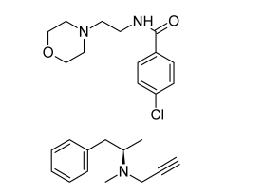
The clinically useful MAOI antidepressants are nonselective between inhibiting metabolism of NE and 5-HT. Agents selective for a MAO that degrades 5-HT have been under study for some time. The structures of phenelzine and tranylcypromine are given in Table 15.4.
Phenelzine Sulfate Phenelzine sulfate, 2-(phenylethyl)hydrazine sulfate (Nardil), is an effective antidepressant agent. A mechanismbased inactivator, it irreversibly inactivates the enzyme or its cofactor, presumably after oxidation to the diazine, which can then break up into molecular nitrogen, a hydrogen atom, and a phenethyl free radical. The latter would be the active species in irreversible inhibition.
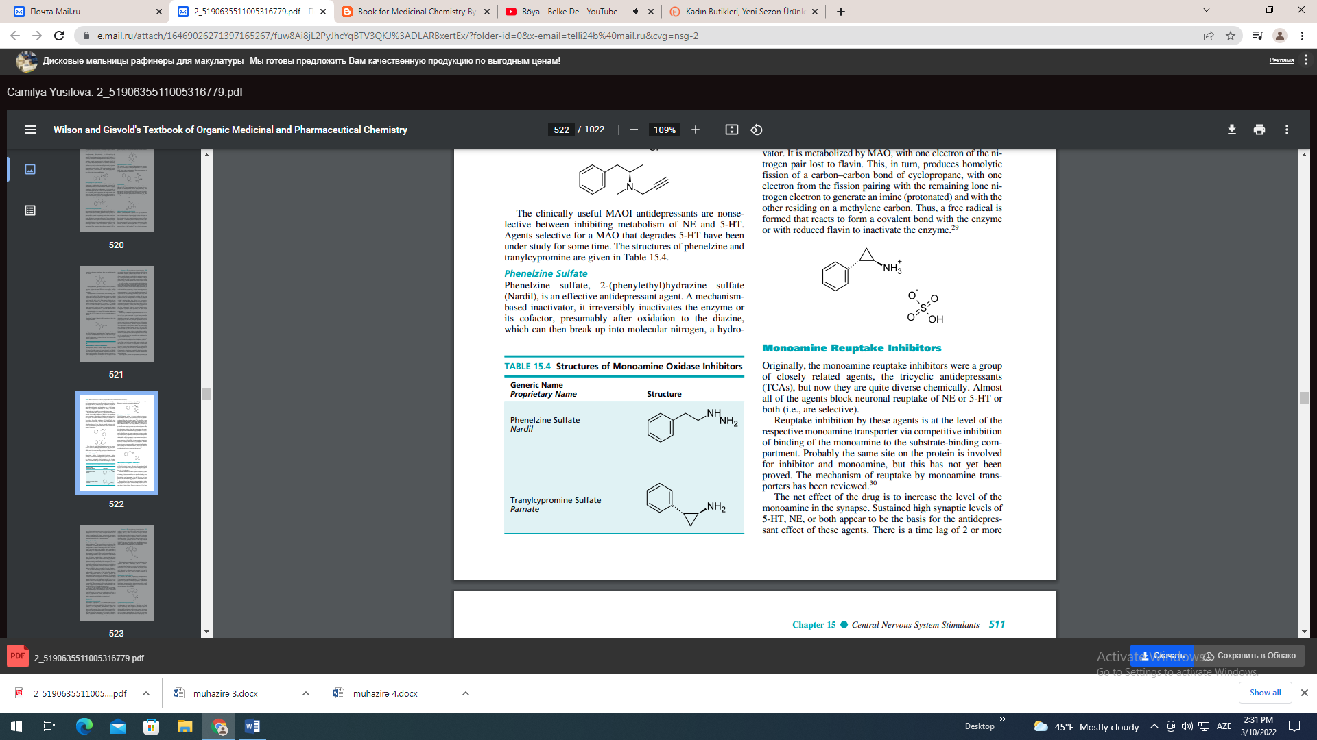
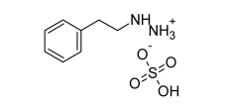
Tranylcypromine Sulfate Tranylcypromine sulfate, trans-2-phenylcyclopropylamine sulfate (Parnate), was synthesized to be an amphetamine analog (visualize the -methyl of amphetamine condensed onto the -carbon atom).26 It does have some amphetamine-like properties, which may be why it has more immediate CNS-stimulant effects than agents that act by MAO inhibition alone. For MAO inhibition, there may be two components to the action of this agent. One is thought to arise because tranylcypromine has structural features (the basic nitrogen and the quasi- character of the - and -cyclopropane carbon atoms) that approximate the transition state in a route of metabolism of -arylamines. As - and -hydrogen atoms are removed from the normal substrate of the enzyme, the quasi-character develops over the carbon system. Duplication of the transition state permits extremely strong, but reversible, attachment to the enzyme. Additionally, tranylcypromine is a mechanism-based inactivator. It is metabolized by MAO, with one electron of the nitrogen pair lost to flavin. This, in turn, produces homolytic fission of a carbon–carbon bond of cyclopropane, with one electron from the fission pairing with the remaining lone nitrogen electron to generate an imine (protonated) and with the other residing on a methylene carbon. Thus, a free radical is formed that reacts to form a covalent bond with the enzyme or with reduced flavin to inactivate the enzyme.
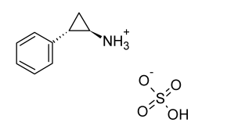
Monoamine Reuptake Inhibitors Originally, the monoamine reuptake inhibitors were a group of closely related agents, the tricyclic antidepressants (TCAs), but now they are quite diverse chemically. Almost all of the agents block neuronal reuptake of NE or 5-HT or both (i.e., are selective). Reuptake inhibition by these agents is at the level of the respective monoamine transporter via competitive inhibition of binding of the monoamine to the substrate-binding compartment. Probably the same site on the protein is involved for inhibitor and monoamine, but this has not yet been proved. The mechanism of reuptake by monoamine transporters has been reviewed.30 The net effect of the drug is to increase the level of the monoamine in the synapse. Sustained high synaptic levels of 5-HT, NE, or both appear to be the basis for the antidepressant effect of these agents. There is a time lag of 2 or more weeks before antidepressant action develops. It is considered that (in the case of 5-HT) 5-HT1A receptors and (in the case of NE) 2 receptors undergo desensitization and transmitter release is maintained. Of course, activation of postsynaptic receptors and sustained transmission is the ultimate result of sustained synaptic levels of neurotransmitter.31 Tricyclic Antidepressants The SARs for the TCAs are compiled in detail in the eighth edition of this text.32 The interested reader is referred to this compilation. In summary, there is a large, bulky group encompassing two aromatic rings, preferably held in a skewed arrangement by a third central ring, and a three- or, sometimes, two-atom chain to an aliphatic amino group that is monomethyl or dimethyl substituted. The features can be visualized by consulting the structures of imipramine and desipramine as examples. The overall arrangement has features that approximate a fully extended trans conformation of the arylamines. To relate these features to the mechanism of action, reuptake block, visualize that the basic arrangement is the same as that found in the -arylamines, plus an extra aryl bulky group that enhances affinity for the substrate-binding compartment of the transporter. The overall concept of a arylamine–like system with added structural bulk, usually an aryl group, appears to be applicable to many newer compounds—selective serotonin reuptake inhibitors (SSRIs), selective norepinephrine reuptake inhibitors (SNERIs)—that do not have a tricyclic grouping. The TCAs are structurally related to each other and, consequently, possess related biological properties that can be summarized as characteristic of the group. The dimethylamino compounds tend to be sedative, whereas the monomethyl relatives tend to be stimulatory. The dimethyl compounds tend toward higher 5-HT to NE reuptake block ratios: in the monomethyl compounds, the proportion of NE uptake block tends to be higher and, in some cases, is considered selective NE reuptake. The compounds have anticholinergic properties, usually higher in the dimethylamino compounds. When treatment is begun with a dimethyl compound, a significant accumulation of the monomethyl compound develops as N-demethylation proceeds. The TCAs are extremely lipophilic and, accordingly, very highly tissue bound outside the CNS. Because they have anticholinergic and noradrenergic effects, both central and peripheral side effects are often unpleasant and sometimes dangerous. In overdose, the combination of effects, as well as a quinidine-like cardiac depressant effect, can be lethal. Overdose is complicated because the agents are so highly protein bound that dialysis is ineffective. PRODUCTS Imipramine Hydrochloride Imipramine hydrochloride, 5-[3-(dimethylamino)propyl]- 10,11-dihydro-5H-dibenz[b,f]azepine monohydrochloride (Tofranil), is the lead compound of the TCAs. It is also a close relative of the antipsychotic phenothiazines (replace the 10–11 bridge with sulfur, and the compound is the antipsychotic agent promazine). It has weaker D2 postsynaptic blocking activity than promazine and mainly affects amines (5-HT, NE, and DA) via the transporters. As is typical of dimethylamino compounds, anticholinergic and sedative (central H1 block) effects tend to be marked. The compound per se has a tendency toward a high 5-HT-to-NE uptake block ratio and probably can be called a serotonin transport inhibitor (SERTI). Metabolic inactivation proceeds mainly by oxidative hydroxylation in the 2-position, followed by conjugation with glucuronic acid of the conjugate. Urinary excretion predominates (about 75%), but some biliary excretion (up to 25%) can occur, probably because of the large nonpolar grouping. Oxidative hydroxylation is not as rapid or complete as that of the more nucleophilic ring phenothiazine antipsychotics; consequently, appreciable N-demethylation occurs, with a buildup of norimipramine (or desimipramine).
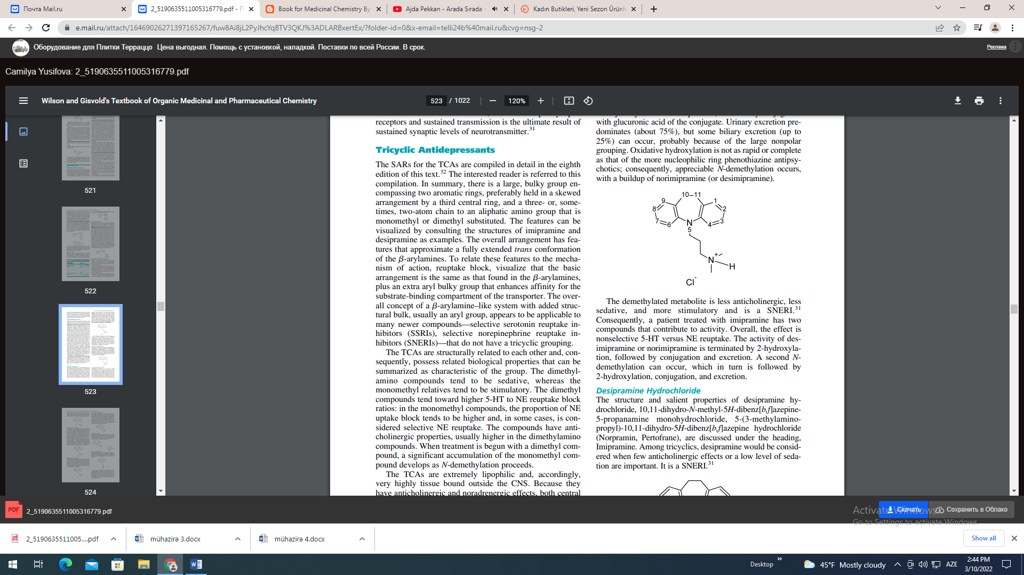
The demethylated metabolite is less anticholinergic, less sedative, and more stimulatory and is a SNERI.31 Consequently, a patient treated with imipramine has two compounds that contribute to activity. Overall, the effect is nonselective 5-HT versus NE reuptake. The activity of desimipramine or norimipramine is terminated by 2-hydroxylation, followed by conjugation and excretion. A second Ndemethylation can occur, which in turn is followed by 2-hydroxylation, conjugation, and excretion. Desipramine Hydrochloride The structure and salient properties of desipramine hydrochloride, 10,11-dihydro-N-methyl-5H-dibenz[b,f]azepine5-propanamine monohydrochloride, 5-(3-methylaminopropyl)-10,11-dihydro-5H-dibenz[b,f]azepine hydrochloride (Norpramin, Pertofrane), are discussed under the heading, Imipramine. Among tricyclics, desipramine would be considered when few anticholinergic effects or a low level of sedation are important. It is a SNERI.
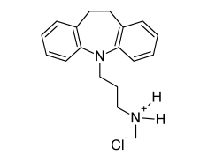

Clomipramine Hydrochloride Clomipramine (Anafranil) is up to 50 times as potent as imipramine in some bioassays. This does not imply clinical superiority, but it might be informative about tricyclic and, possibly, other reuptake inhibitors. The chloro replacing the H-substituent could increase potency by increasing distribution to the CNS, but it is unlikely that this would give the potency magnitude seen. It might be conjectured that an H-bond between the protonated amino group (as in vivo) and the unshared electrons of the chloro substituent might stabilize a -arylamine–like shape and give more efficient competition for the transporter. The drug is an antidepressant. It is used in obsessive–compulsive disorder, an anxiety disorder that may have an element of depression.
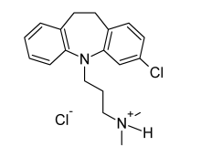
Amitriptyline Hydrochloride Amitriptyline, 3-(10,11-dihydro-5H-dibenzo[a,d]cyclohepten-5-ylidene)-N,N-dimethyl-1-propanamine hydrochloride, 5-(3-dimethylaminopropylidene)-10,11-dihydro-5Hdibenzo[a,d]cycloheptene hydrochloride (Elavil), is one of the most anticholinergic and sedative of the TCAs. Because it lacks the ring-electron–enriching nitrogen atom of imipramine, metabolic inactivation mainly proceeds not at the analogous 2-position but at the benzylic 10-position (i.e., toluene-like metabolism predominates). Because of the 5- exocyclic double bond, E- and Z-hydroxy isomers are produced by oxidation metabolism. Conjugation produces excretable metabolites. As is typical of the dimethyl compounds, N-demethylation occurs, and nortriptyline is produced, which has a less anticholinergic, less sedative, and more stimulant action than amitriptyline. Nortriptyline is a SNERI31; the composite action of drug and metabolite is nonselective.
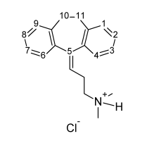
Nortriptyline Hydrochloride Pertinent biological and chemical properties for nortriptyline, 3- (10,11- dihydro - 5H – dibenzo [a,d] cyclohepten-5-ylidene)Nmethyl-1-propanamine hydrochloride, 5-(3-methyl-aminopropylidene) -10,11-hydro-5H-dibenzo[a,d] cycloheptene hydrochloride (Aventyl, Pamelor), are given previously in the discussion of amitriptyline. Metabolic inactivation and elimination are like those of amitriptyline. Nortriptyline is a selective NE transporter (NET) inhibitor.

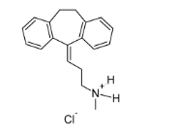
Protriptyline Hydrochloride Protriptyline hydrochloride, N-methyl-5H-dibenzo[a,d]- cycloheptene-5-propylamine hydrochloride, 5-(3-methylaminopropyl)-5H-dibenzo[a,d]cycloheptene hydrochloride (Vivactil), like the other compounds under consideration, is an effective antidepressant. The basis for its chemical naming can be seen by consulting the naming and the structure of imipramine. Protriptyline is a structural isomer of nortriptyline. Inactivation can be expected to involve the relatively localized double bond. Because it is a monomethyl compound, its sedative potential is low.
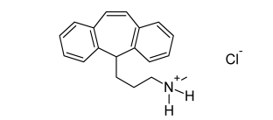
Trimipramine Maleate
For details of chemical nomenclature, consult the description of imipramine. Replacement of hydrogen with an -methyl substituent produces a chiral carbon, and trimipramine (Surmontil) is used as the racemic mixture. Biological properties reportedly resemble those of imipramine. Doxepin Hydrochloride Doxepin, 3-dibenz[b,e]-oxepin-11(6H)ylidine-N,N-dimethyl1-propanamine hydrochloride, N,N-dimethyl-3-(dibenz[b,e] oxepin-11(6H)-ylidene)propylamine (Sinequan, Adapin), is an oxa congener of amitriptyline, as can be seen from its structure.
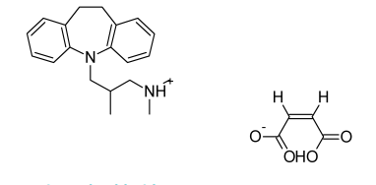

Doxepin Hydrochloride Doxepin, 3-dibenz[b,e]-oxepin-11(6H)ylidine-N,N-dimethyl1-propanamine hydrochloride, N,N-dimethyl-3-(dibenz[b,e] oxepin-11(6H)-ylidene)propylamine (Sinequan, Adapin), is an oxa congener of amitriptyline, as can be seen from its structure.
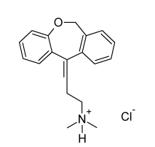

The oxygen is interestingly placed and should influence oxidative metabolism as well as postsynaptic and presynaptic binding affinities. The (Z)-isomer is the more active, although the drug is marketed as the mixture of isomers. The drug overall is a NE and 5-HT reuptake blocker with significant anticholinergic and sedative properties. It can be anticipated that the nor- or des- metabolite will contribute to the overall activity pattern.
Maprotiline Hydrochloride Maprotiline hydrochloride, N-methyl-9, 10-ethanoanthracene (10H)-propanamine hydrochloride (Ludiomil), is sometimes described as a tetracyclic rather than a tricyclic antidepressant. The description is chemically accurate, but the compound, nonetheless, conforms to the overall TCA pharmacophore. It is a dibenzobicyclooctadiene and can be viewed as a TCA with an ethylene-bridged central ring. The compound is not strongly anticholinergic and has stimulant properties. It can have effects on the cardiovascular system. It is a SNERI.
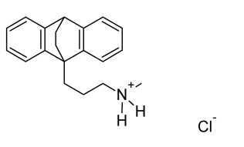
Amoxapine
Consideration of the structure of amoxapine, 2-chloro-11- (1-piperazinyl)dibenz-[b,f] [1,4]oxazepine (Asendin), reinforces the fact that many antidepressants are very closely related to antipsychotics. Indeed, some, including amoxapine, have significant effects at D2 receptors. The Nmethyl–substituted relative of amoxapine is the antipsychotic loxapine (Loxitane). The 8-hydroxy metabolite of amoxapine is reportedly active as an antidepressant and as a D2 receptor blocker.
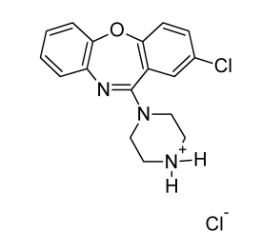

Selective Serotonin Reuptake
Inhibitors
Structurally, the SSRIs differ from the tricyclics, in that the tricyclic system has been taken apart in the center. (This abolishes the center ring, and one ring is moved slightly forward from the tricyclic “all-in-a-row” arrangement.) The net effect is that the arylamine–like grouping is present, as in the tricyclics, and the compounds can compete for the substratebinding site of the serotonin transporter protein (SERT). As in the tricyclics, the extra aryl group can add extra affinity and give favorable competition with the substrate, serotonin. Many of the dimethylamino tricyclics are, in fact, SSRIs. Because they are extensively N-demethylated in vivo to norcompounds, which are usually SNERIs, however, the overall effect is not selective. Breaking up the tricyclic system breaks up an anticholinergic pharmacophoric group and gives compounds with diminished anticholinergic effects. Overall, this diminishes unpleasant CNS effects and increases cardiovascular safety. Instead, side effects related to serotonin predominate. Fluoxetine In fluoxetine (Prozac), protonated in vivo, the protonated amino group can H-bond to the ether oxygen electrons, which can generate the -arylamino–like group, with the other aryl serving as the characteristic “extra” aryl. The S-isomer is much more selective for SERT than for NET. The major metabolite is the N-demethyl compound, which is as potent as the parent and more selective (SERT versus NET). Therapy for 2 or more weeks is required for the antidepressant effect. Somatodendritic 5-HT1A autoreceptor desensitization with chronic exposure to high levels of 5-HT is the accepted explanation for the delayed effect for this and other serotonin reuptake inhibitors.

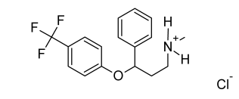

To illustrate a difference between selectivity for a SERT and a NET, if the para substituent is moved to the ortho position (and is less hydrophobic, typically), a NET is obtained. This and other SERTs have anxiolytic activity. One of several possible mechanisms would be agonism of 5-HT1A receptors, diminishing synaptic 5-HT. Presumably, synaptic levels of 5-HT might be high in an anxious state. Paroxetine In the structure of paroxetine (Paxil), an amino group, protonated in vivo could H-bond with the –CH2–O– unshared electrons. A arylamine–like structure with an extra aryl group results. The compound is a very highly selective SERT. As expected, it is an effective antidepressant and anxiolytic.

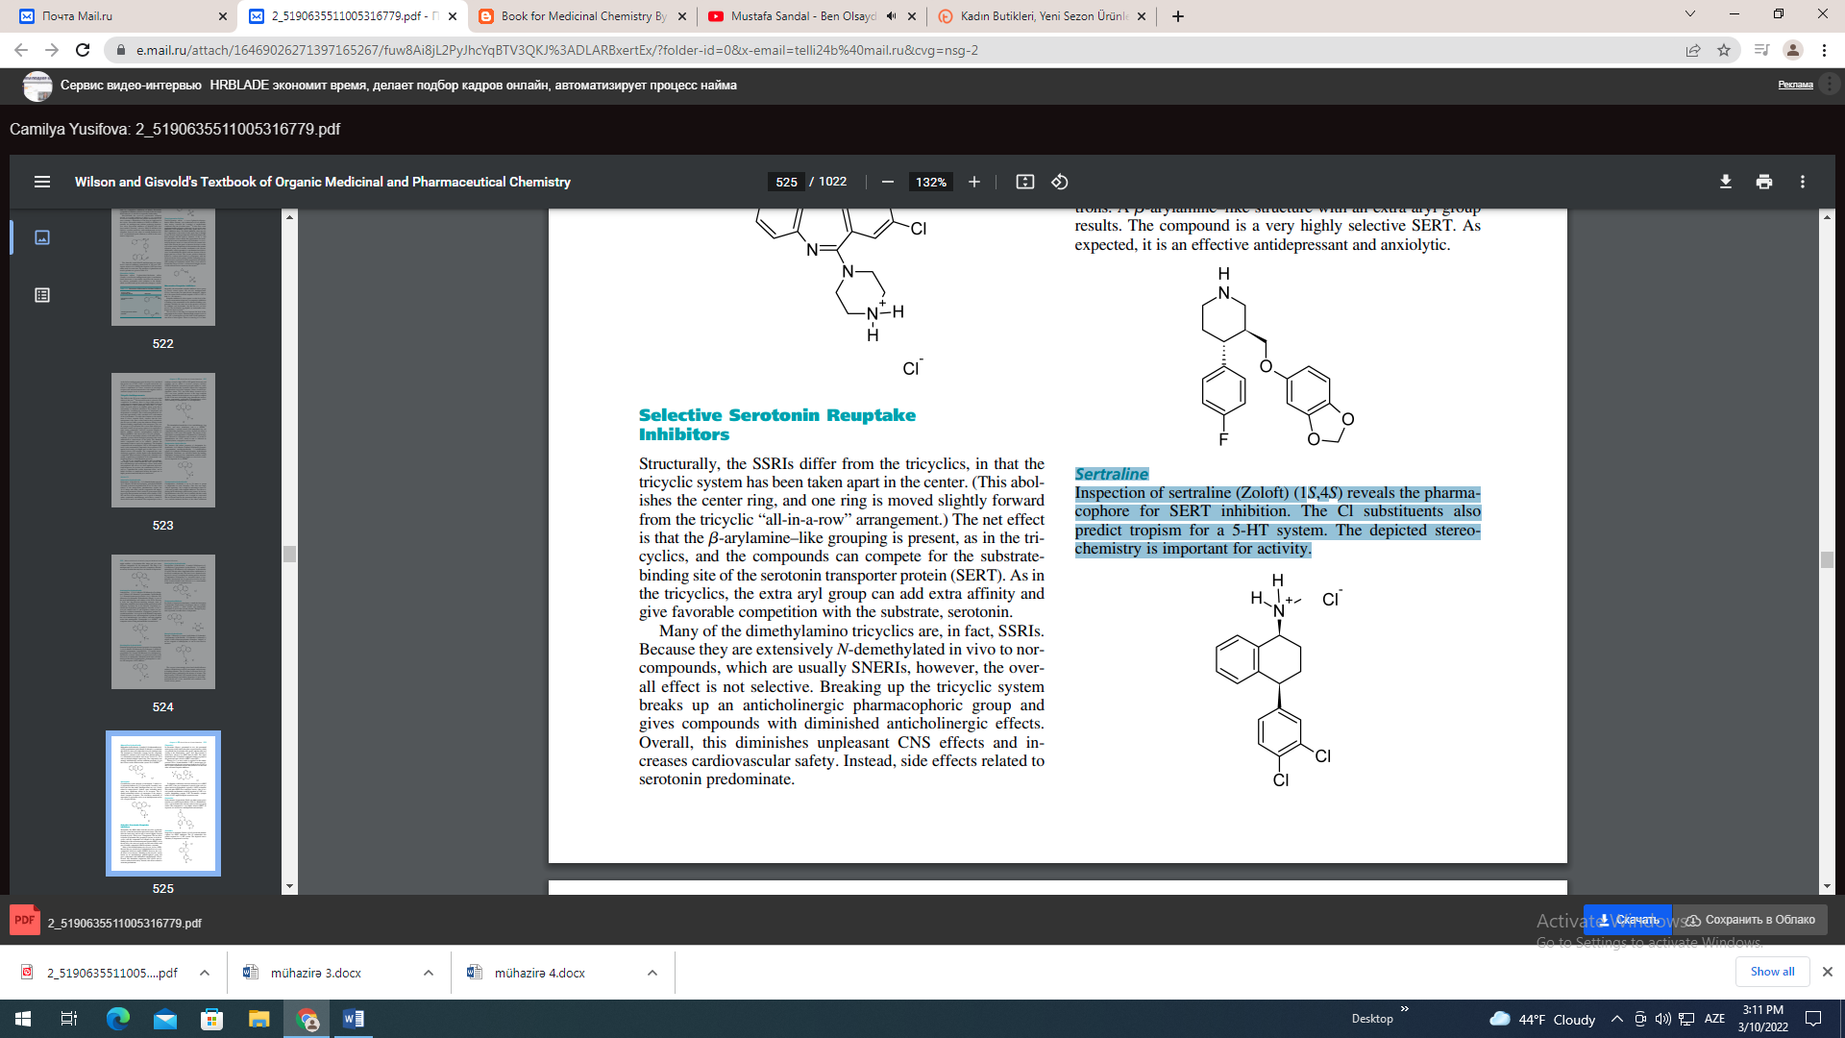

Sertraline Inspection of sertraline (Zoloft) (1S,4S) reveals the pharmacophore for SERT inhibition. The Cl substituents also predict tropism for a 5-HT system. The depicted stereochemistry is important for activity.
Fluvoxamine
The E-isomer of fluvoxamine (Luvox) (shown) can fold after protonation to the arylamine–like grouping. Here, the “extra” hydrophobic group is aliphatic.
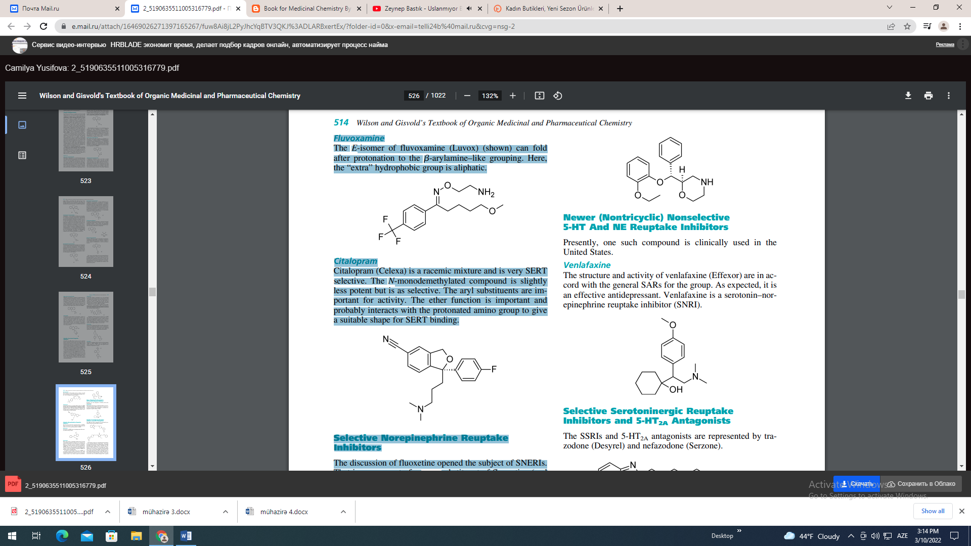
Citalopram Citalopram (Celexa) is a racemic mixture and is very SERT selective. The N-monodemethylated compound is slightly less potent but is as selective. The aryl substituents are important for activity. The ether function is important and probably interacts with the protonated amino group to give a suitable shape for SERT binding.
Selective Norepinephrine Reuptake Inhibitors The discussion of fluoxetine opened the subject of SNERIs. That is, movement of a para substituent of fluoxetine (and relatives) to an ortho position produces a SNERI. Nisoxetine Nisoxetine is a SNERI and is an antidepressant. Most activity resides in the isomer.
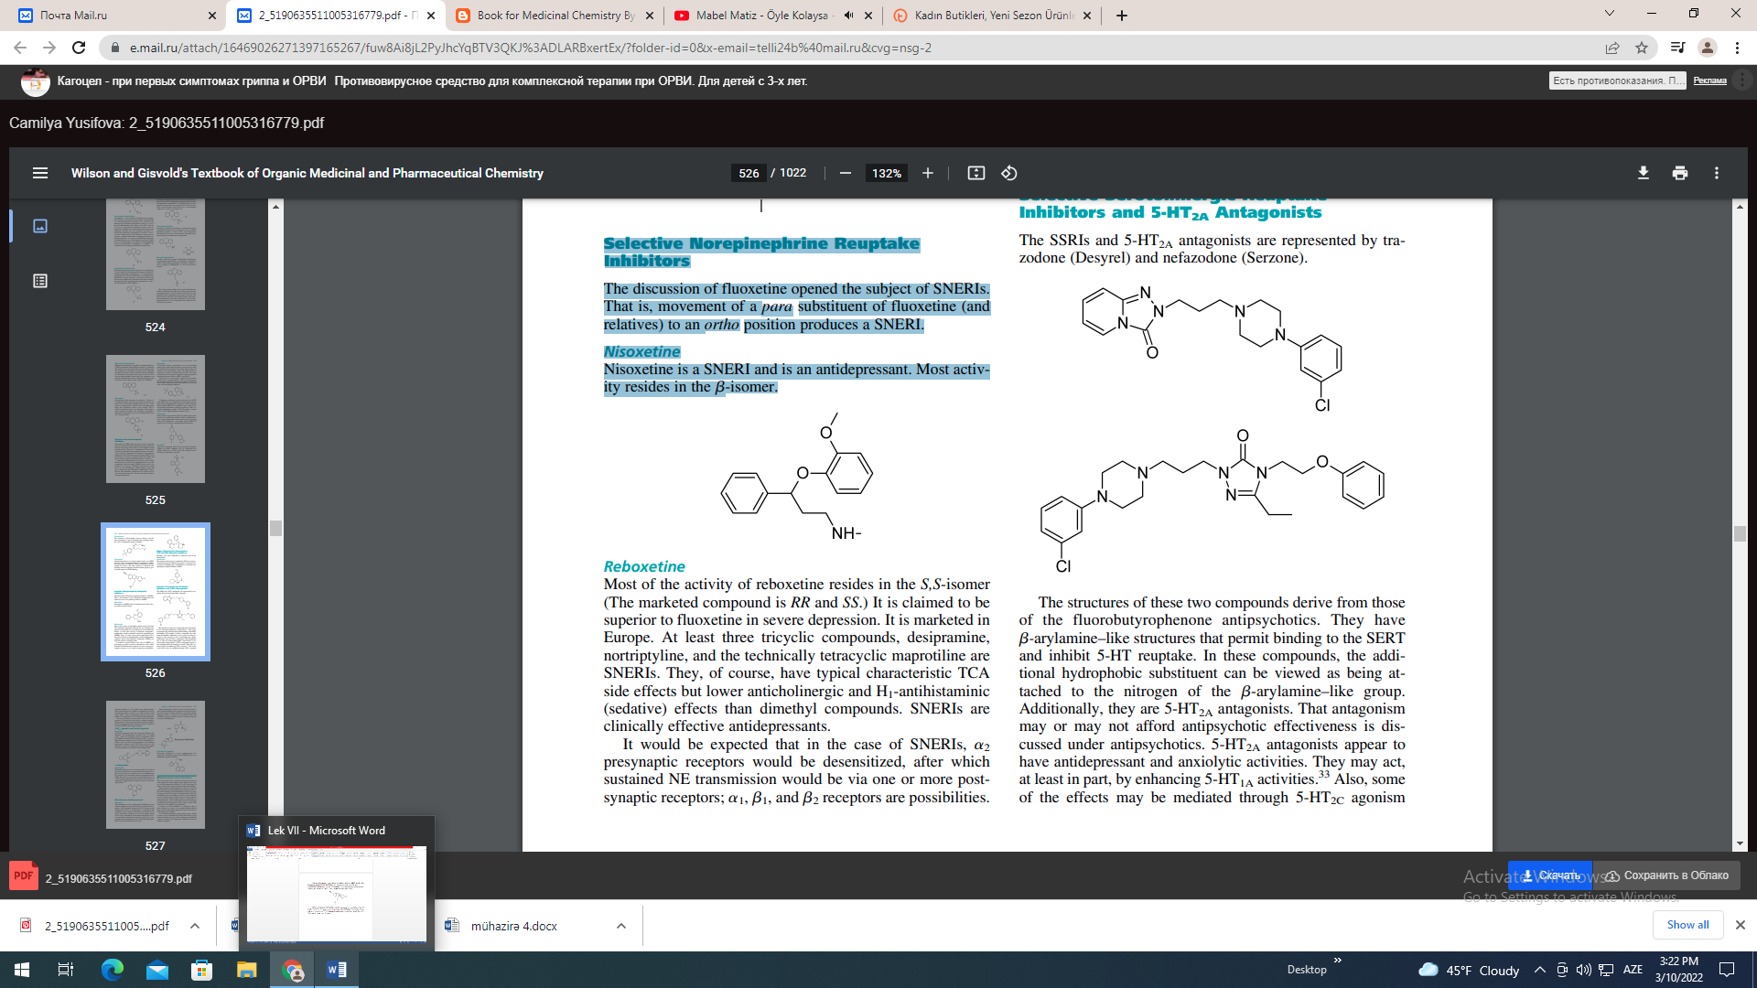
Reboxetine
Most of the activity of reboxetine resides in the S,S-isomer (The marketed compound is RR and SS.) It is claimed to be superior to fluoxetine in severe depression. It is marketed in Europe. At least three tricyclic compounds, desipramine, nortriptyline, and the technically tetracyclic maprotiline are SNERIs. They, of course, have typical characteristic TCA side effects but lower anticholinergic and H1-antihistaminic (sedative) effects than dimethyl compounds. SNERIs are clinically effective antidepressants. It would be expected that in the case of SNERIs, 2 presynaptic receptors would be desensitized, after which sustained NE transmission would be via one or more postsynaptic receptors; 1, 1, and 2 receptors are possibilities.
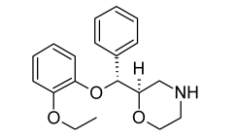
Newer (Nontricyclic) Nonselective 5-HT And NE Reuptake Inhibitors Presently, one such compound is clinically used in the United States. Venlafaxine The structure and activity of venlafaxine (Effexor) are in accord with the general SARs for the group. As expected, it is an effective antidepressant. Venlafaxine is a serotonin–norepinephrine reuptake inhibitor (SNRI).
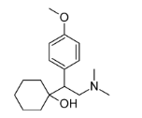
Selective Serotoninergic Reuptake Inhibitors and 5-HT2A Antagonists The SSRIs and 5-HT2A antagonists are represented by trazodone (Desyrel) and nefazodone (Serzone).

The structures of these two compounds derive from those of the fluorobutyrophenone antipsychotics. They have arylamine–like structures that permit binding to the SERT and inhibit 5-HT reuptake. In these compounds, the additional hydrophobic substituent can be viewed as being attached to the nitrogen of the arylamine–like group. Additionally, they are 5-HT2A antagonists. That antagonism may or may not afford antipsychotic effectiveness is discussed under antipsychotics. 5-HT2A antagonists appear to have antidepressant and anxiolytic activities. They may act, at least in part, by enhancing 5-HT1A activities.33 Also, some of the effects may be mediated through 5-HT2C agonism (perhaps generally so for 5-HT–acting antidepressants). Some of the side effects of SSRIs are considered to be mediated through 5-HT2A receptors, so a 5-HT2A blocker would reduce them.33 The two compounds yield the same compound on N-dealkylation. It is a serotonin reuptake inhibitor. The most common use of trazodone is not as an antidepressant. A 100-mg dose can be used as a sedative–hypnotic. Despite this use, it has been shown that nefazodone produces better sleep hygiene than does trazodone, which is a rapid eye movement (REM)-suppressing compound.
5-HT1A Agonists and Partial Agonists Buspirone
The initial compound in this series, buspirone (BuSpar), has anxiolytic and antidepressant activities and is a partial 5-HT1A agonist. Its anxiolytic activity is reportedly caused by its ability to diminish 5-HT release (via 5-HT1A agonism). High short-term synaptic levels of 5-HT are characteristic of anxiety. Also, because it is a partial agonist, it can stimulate postsynaptic receptors when 5-HT levels are low in the synapse, as is the case in depression. Several other spirones are in development as anxiolytics and antidepressants.
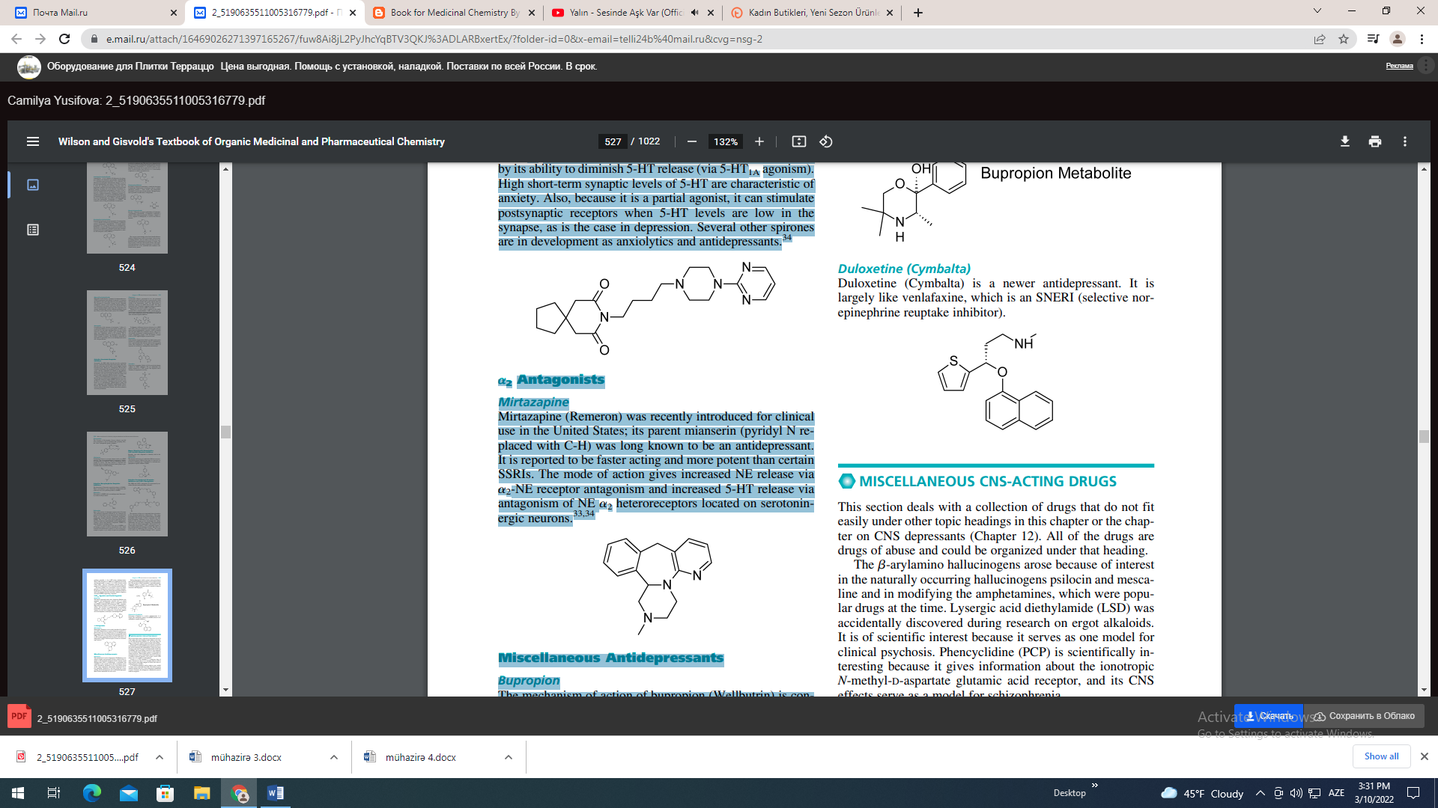
Antagonists Mirtazapine Mirtazapine (Remeron) was recently introduced for clinical use in the United States; its parent mianserin (pyridyl N replaced with C-H) was long known to be an antidepressant. It is reported to be faster acting and more potent than certain SSRIs. The mode of action gives increased NE release via 2-NE receptor antagonism and increased 5-HT release via antagonism of NE 2 heteroreceptors located on serotoninergic neurons.
Miscellaneous Antidepressants Bupropion The mechanism of action of bupropion (Wellbutrin) is considered complex and reportedly involves a block of DA reuptake via the dopamine transporter (DAT), but the overall antidepressant action is noradrenergic. A metabolite that contributes to the overall action and its formation can be easily rationalized. Oxidation of one of the methyl groups on the t-butyl substituent yields hydroxybupropion, an active metabolite. Reduction of the keto group also occurs, yielding threohydrobupropion and erythrohydrobupropion. Both of these metabolites are also active. Hydroxybupropion is half as potent as the parent bupropion, and the hydrobupropion isomers are five times less potent. The presence of these metabolites, especially hydroxybupropion which is formed by cytochrome P450 2D6 (CYP2D6), suggests that there will be a myriad of drug interactions with bupropion.

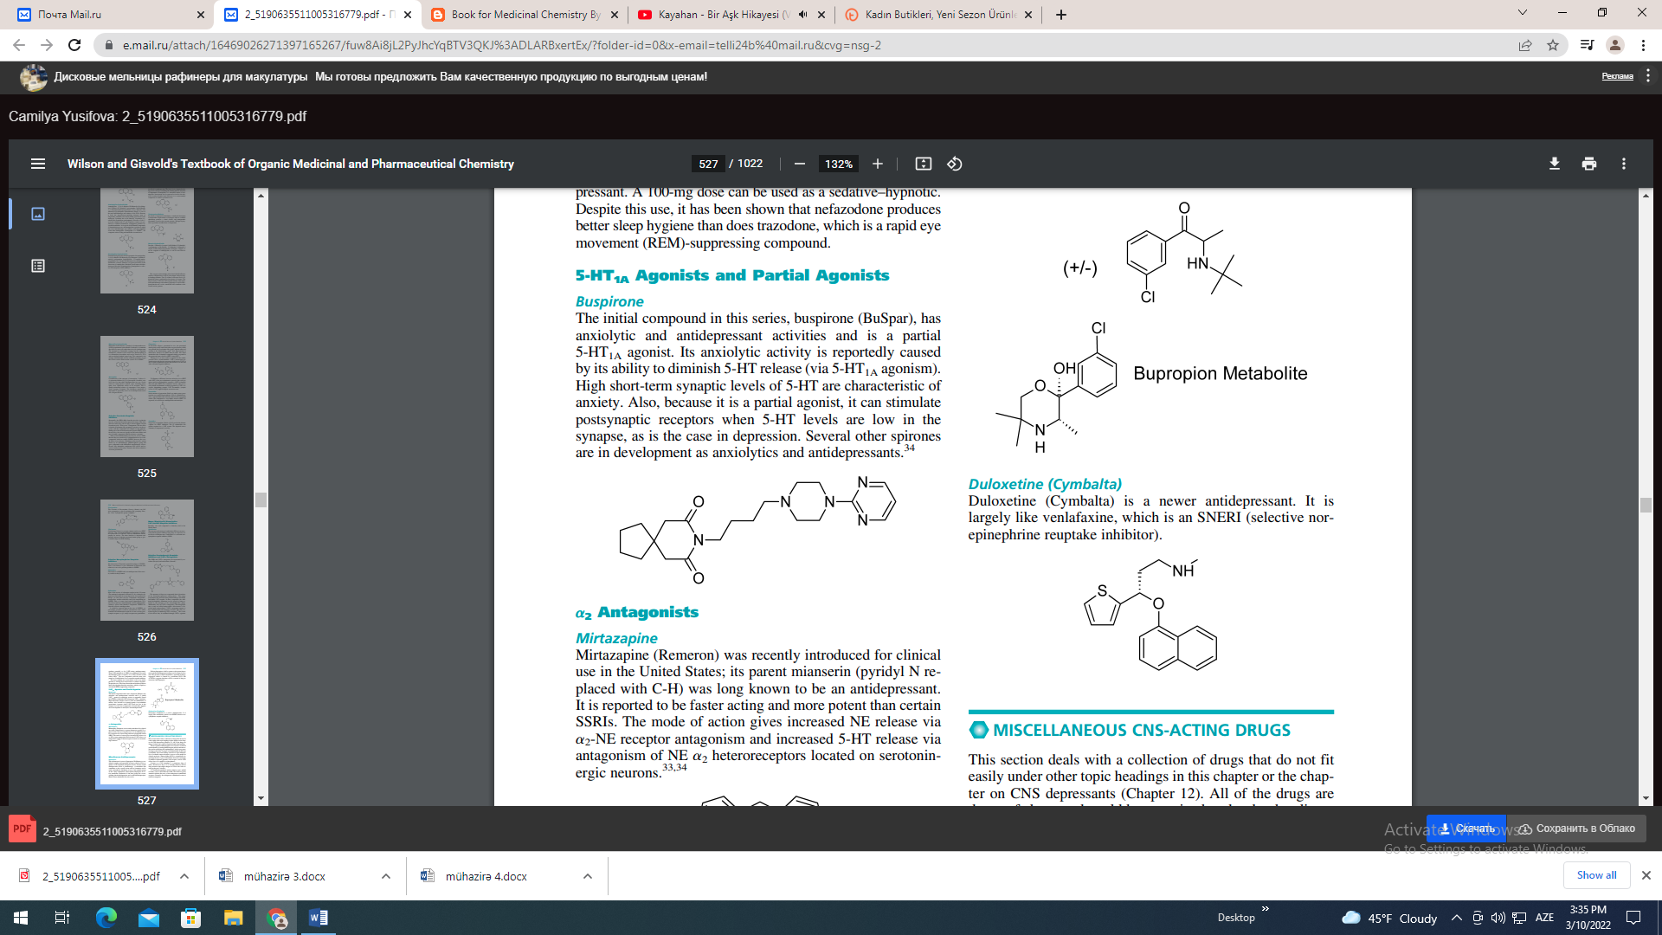

Duloxetine (Cymbalta) Duloxetine (Cymbalta) is a newer antidepressant. It is largely like venlafaxine, which is an SNERI (selective norepinephrine reuptake inhibitor).

